Burbage  Neighbourhood Development Plan | 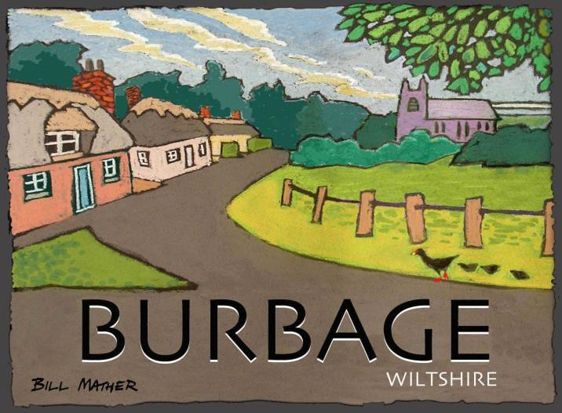
Burbage Parish 2014 – 2026
Site Selection Report

Regulation 14 Consultation Draft

CONTENTS

1.0 Introduction and Overview Map 5

2.0 Methodology 6

3.0 Formal Site Selection Process 9

4.0 Sites Selected for Pre-Submission Draft 16

5.0 Sites deleted or added after Regulation 14 Consultation (when available) 17

6.0 Final list of sites going forward into Submission Draft Plan (when available) 17

Appendix 1 Evidence Base

Appendix 2 Extract from Village Survey

Appendix 3 Original hand annotated site maps

Appendix 4 Detailed Sites Map

Glossary of Terms

BNDP Burbage Neighbourhood Development Plan
CA Community Area
Community Engagement Survey Initial community engagement survey of 2014
HNS Housing Needs Survey for Burbage
HRA Habitat Regulations Assessment
LoD Limit of Development (e.g. village boundary)
LPA Local Planning Authority (Wiltshire Council)
NDP Neighbourhood Development Plan
NPPF National Planning Policy Framework - The Framework' sets out planning policies for England and how they are expected to be applied. It provides guidance for local planning authorities and decision-takers, both in drawing up plans and making decisions about planning applications.
PC Parish Council
PPG Planning Practice Guidance
Qualifying Body Body authorized by law to create a Neighbourhood Plan. Normally the Parish Council.
Reg. 14 / 15 Regulation 14 of the Neighbourhood Plan (General) Regulations 2012 requires that a formal 6-week Consultation be carried out. Regulation 15 Requires a Consultation Statement to be submitted.
SA Sustainability Appraisal – A wide-ranging appraisal of the impacts of policy (such as this plan) to include socio-economic as well as environmental factors.
SEA Strategic Environmental Assessment – European legislation requiring all plans to be assessed for environmental effects. In the UK compliance with the SEA Regulations can be achieved through SA or Sustainability Appraisal which takes into account socio-economic as well as environmental factors.
SSR Site Selection Report
SHLAA Strategic Housing Land Availability Assessment
WCS Wiltshire Core Strategy

Burbage Neighbourhood Plan Site Selection Process

1.0 Introduction

1.0 Planning Practice Guidance, paragraph 42 states that, in order to allocate sites in a Neighbourhood Plan, a qualifying body should carry out an appraisal of options and an assessment of individual sites against ‘clearly identified criteria’. These criteria are not specified. However, advice concerning viability and land suitability are given in the PPG’s linked paragraphs. These relate mainly to Local Plans, and the guidance acknowledges that the process for a Neighbourhood Plan is expected to be ‘proportionate’ - that is, fit for purpose but not so overly complex as to be onerous.

1.1 Compared with a Local Plan, the process will in any case, inevitably be different for a Neighbourhood Plan. The objective of a typical site selection exercise in a Local Plan (which can be taken to include the SHLAA, SHMA and other procedures) is essentially a general screening of all possible sites. Moreover, when carrying out the process, the LPA would have firmly in mind the strategic target figure for housing expected by central government and by its own calculations regarding need. By its very nature therefore a Local Plan site selection process is a long drawn out and comprehensive affair.

1.2 For a Neighbourhood Plan however, a much simpler process is appropriate, not least because, while it cannot propose less development than the Development Plan, it only has to consider sites that the community will support, and not every possible site. Since it is not desirable to duplicate work done at higher levels, a Neighbourhood Plan can also draw on evidence other than that created by its own research – in this case such research includes recent evidence from the Wiltshire Core Strategy published in 2015.

1.3 In the case of the Burbage Neighbourhood Plan it was decided to also consider which sites, if any, should be formally designated Green Space. This careful consideration was necessary as, while the community suggested a number of possibilities, the NPPF makes it clear that this power must be used sparingly.

Overall Distribution of Sites

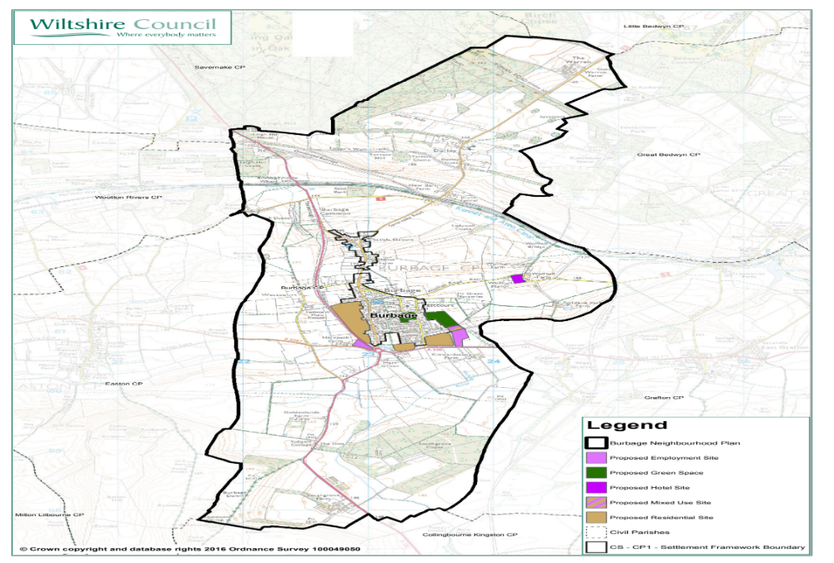

2.0 Methodology

2.0 The objective of a Neighbourhood Plan site assessment should be to test sites that are acceptable to the community that are in general conformity with the Development Plan and to then show that they are practicable in land-use terms, environmentally sustainable and realistically achievable. As such the relevant stage of the methodology suggested in PPG ‘Housing and Economic Land Availability Assessment’ is stage 2, although the interpretation of the stage is proportionate (for example the NDP is prepared within the influence and evidence base of the WCS and there is no need to repeat this).

2.1 The following assessment is therefore concerned with examining the planning or land-use implications of each housing or employment site. Environmental constraints and overall sustainability of each site is assessed separately in the SA. All sites were screened for HRA as part of the overall screening of the NDP and this information is given as Appendix 2 of the NDP.

2.2 The key elements of Stage 2, as considered appropriate criteria for housing or employment site selection in the NDP are:

- Physical Site Constraints – matters such as safe access, topography, physical impediments to using the site and so on.

- Development potential – Type and quantum suitable for the site. This would normally relate to the criteria in the Wiltshire Core Strategy (WCS) and the Local Plan. However, the WCS does not specify densities and the Kennet Local Plan (KLP) does not require higher densities in Burbage. The WCS stresses design matters, stating that density should be determined on a site by site basis in relation to local characteristics. In view of this, site allocations are given with a range of indicative dwelling numbers. When considering density local community wishes will also be taken into account.

- Market needs – Attractiveness of the site to developers - as determined both by the Wiltshire Strategic Housing Market Assessment (SHMA) 2011 (e.g. 4.31 - 4.33), through knowledge of Steering Group, by evidence from recent development pressure and by consultation with land agents and developers during formal consultation.

- Regeneration / land Improvement aims – removal of local eyesores, regeneration of lower quality areas of townscape and improvement of local economy to create local jobs (improving self-containment) is desirable and has been considered for each site.

- Use proposed and resulting Life Quality of both potential occupiers and neighbours – What use would be appropriate? What would it be like to live or work on the site once built? What would the effect be on existing properties? A site visit by the Steering Group was made to every site to answer these important questions.

- Availability – Determining availability can be a time consuming and lengthy process and to implement this fully would not be ‘proportionate’ for a Neighbourhood Plan. The methodology used to assess this criteria therefore is that the site should be known locally to be available and the owners and land agents be invited to comment during consultation. Unless information is received to the contrary sites will be assumed to be available.

- Viability – while stressing that viability – economic realism - is important, guidance does not require every site to be individually assessed for viability. The approach for the Plan is therefore to check each site type (residential / employment / infill, greenfield, PDL etc.) against the viability assessment used for the Wiltshire Core Strategy – WCS- (specifically ‘Wiltshire Local Plan Viability Study, February 2014’) to ensure that the site is viable if it is to provide an acceptable return while delivering CIL, affordable housing and other policy requirements.

In fact the area covered by the NDP is classified in the WCS viability assessment as ‘Category 1’ – the area of highest returns. This suggests that all types of housing sites – as shown in Tables 11.0, 11.2 and 12.1 of the above, are likely to be viable even up beyond the highest level of affordable housing requirement. There is therefore some headroom to absorb additional costs, and developer contributions if required, in proportion to the scheme, and no housing site is likely to be unviable if these are fairly negotiated.

2.3 The situation is very different however in the case of employment development – with low levels of viability for most uses, with the notable exception of hotels. While the desire of the community to provide additional employment opportunities in not in doubt, whether this can be delivered under current market conditions is doubtful. The approach of the Steering Group and this Site Selection Report to this has been two-fold:

- To accept that some element of subsidy from housing may be required to deliver employment sites (i.e. to accept mixed use schemes rather than pure employment ones).

- To nevertheless allocate some employment-only sites based on:

- local experience of demand (some sites are full)
- existing employment uses being already present (the assumption being that the extension of sites rather than creation of fresh ones
would be less costly and so more viable)
- The hope and belief that economic conditions will improve. The NDP runs until 2026 so this is a clear possibility.

2.4 Additionally, the input of developers and land agents on the topic of viability will be sought prior to and during the formal consultation process and developers would of course remain free to challenge the viability of specific schemes through the planning applications process.

2.5 Timescale – Timescale for delivery is not assessed and is assumed to be within the lifetime of the plan, which runs for some considerable time ahead, to 2026, in parallel with the WCS.

2.6 WCS / KLP - sites identified by the WCS or the KLP will not generally be considered, to avoid duplication.

2.7 Environmental topics and the question of sustainability, including socio-economic impacts, will be assessed for each site via the SA. This is a separate process to the strictly land use planning assessment given in this report. A site will only be acceptable if it is demonstrated to deliver sustainable development as demonstrated by the SA. The Burbage SA is submitted as a separate document alongside the NDP.

3.0 Formal Site Selection Process for Housing and Actual Site Selection

3.0 The following table was used to assess sites for housing and employment development, using the above planning criteria prior to sites being included in the pre-submission draft NDP. In order to ‘pass’ and be considered acceptable, a site would normally have to receive a positive comment or tick in every column shaded green with the exception of ‘Regeneration’ (since, while desirable, the latter attribute is not essential to deliver the strategy of the plan).

3.1 Site selection began with the first survey, and comments and suggestions from this were taken forward (see Appendix 2). Broadly speaking the survey indicated:

- An appetite for some housing growth (the majority stating more than 25 homes were needed)
- A desire for more employment - based ideally on consolidating or expanding existing employment areas
- Development within and outside the village boundary is acceptable
- Brownfield sites should be considered
- The land between the village and the bypass should be considered
- Limited development could take place in the hamlets of the parish

The full survey is included in the Consultation Statement.

3.2 Later, a workshop session of the Steering Group was followed by site visits and a further meeting. The objective was to identify practical possibilities including sites that might reasonably obtain public support (based on survey responses and known attitudes from past parish Council meetings) in order to fuel an ongoing debate during the future evolution of the NDP. It was accepted and indeed hoped for and expected, that alternatives and additional sites would be suggested during consultation by the community. Hand-drawn boundaries were hand-sketched onto maps covering; development sites in the village, sites in the wider parish and Local Green Space sites.

3.3 Initial site assessment proper began with site visits by the Steering Group chairman and planning consultant, during which the above maps were used and forms based on the tables below formed the basis for assessing each housing, employment and potential local green space site. Sites were also named and these names put on the maps. These named maps, given as Appendix 3, therefore show the range of sites initially considered.

3.4 Following the site visits, a desk-based analysis was carried out by the Planning Consultant, completing the rest of the tables, and referring to the evidence base shown in Appendix 1, which are given below, and to rough notes made during the site visits. Recommendations were then made to the Steering Group, and a revised overall sites map was then created to identify the sites to actually go forward for public consultation. (Appendix 4).
3.5 At this stage compliance with WCS policies was not checked. This was because:

  - The main objective initially was to identify sites acceptable to the community
  - No strategic WCS or saved sites from the KLP are in the area
  - The quantum of development proposed is higher than that of the WCS

Sites and policies must however be in general conformity with the Development Plan and indeed Government policy, and this will be formally checked as part of the formal Regulation 14 consultation with the LPA.

3.6 Sites that passed this initial planning assessment were then later assessed by SA (see separate SA Environmental report).

3.7 During Regulation 14 Consultation landowners were consulted…. ADD DETAILS WHEN AVAILABLE

3.8 Following Regulation 14 consultation…. ADD DETAILS WHEN AVAILABLE

ADD HERE DETAILS OF ANY MORE REVISIONS. Including Appendix locations of new and final maps.

3.9 Sites that finally form part of the NDP have therefore been extensively tested against the WCS evidence base, local knowledge, consultation inputs including developers and land agents / owners (subject to their responding), the Statutory Consultees (English Heritage, Environment Agency and Natural England) as well as the LPA, and a formal sustainability appraisal process via SA. They will also have been screened for HRA compliance. This is considered to be an adequate process for a Neighbourhood Plan of this scale.

Initial Housing, Employment and Mixed Use Site Suitability Selection

Site  Name or Address | Description  Current Use / History | Description  Development Potential  type / quantum | WCS or KLP Site? | Site Constraints  Describe,  (indicate if mitigation possible. Tick if so). | Site Benefits | Regeneration?  Tick or cross plus notes | Market Needs?  Tick or cross plus notes | Life Quality?  Tick or cross plus notes | Availability?  Tick or cross plus notes | Viability?  Tick or cross plus notes from WCS Viability Assessment plus local knowledge of demand | PASS/ FAIL
North Seymour | Since original selection, site now granted permission for Persimmon housing development of 45 houses. Site therefore withdrawn (W/D) from selection process. |  |  |  |  |  |  |  |  |  | W/D
Grafton Road | Agriculture  Arable. | Housing – 15 units? | No | √  AONB (but on edge of urban area)  Outside village boundary (but with building on 2 sides)  Access? (possible through Persimmon site?  Greenfield | √  Flat, clear. Existing mature screening.  Well related to rest of village and local amenities. | X | √  HNS (Feb 2014).  Wiltshire SHMA.  Strong developer interest in Burbage (e.g. N. Seymour site adjacent). | √  Unlikely to cause probs. for existing properties, but screening and separation needed for dwellings to the south | √?  Crown Estates?  (CE have recently sold land in Burbage) | √ | PASS
Mundy’s Yard and Scout Hut | Builders Yard and adjacent scout hut. Yard generates traffic dust & noise in existing residential neighbourhood. Yet facility itself (which supplied DIY materials) is popular within the village. Scout hut popular yet dilapidated. | Mixed use development  Up to 20 houses plus small number of offices.  Relocate existing uses (e.g.Mundy’s to Hirata site, Scout Hut to Red Lion Field. | No | √  AONB (but on edge of urban area)  Brownfield. Contamination. (Mitigation Possible). | √  Brownfield. Services ready. Reduction in noise, traffic and dust if yard moved to new location. close to local amenities, within village boundary & by bus and paths.  Good road access. | √  Yes, would enable expansion of business and consolidation of employment Area if moved to old Hirata site.. | √  HNS (Feb 2014).  Wiltshire SHMA.  Strong developer interest in Burbage. Mundy’s has been considering re-location for some time. | √  Would improve life quality for local residents. | √? | √? | PASS  (non-housing uses would have to be modest element)

Site  Name or Address | Description  Current Use / History | Description  Development Potential  type / quantum | WCS or KLP Site? | Site Constraints  Describe,  (indicate if mitigation possible. Tick if so). | Site Benefits | Regeneration?  Tick or cross plus notes | Market Needs?  Tick or cross plus notes | Life Quality?  Tick or cross plus notes | Availability?  Tick or cross plus notes | Viability?  Tick or cross plus notes from WCS Viability Assessment | PASS/ FAIL
By-Pass Site | Agriculture. Rough pasture. Poor land quality. | Housing (80 homes) development with green spaces and wildlife habitat enhancement.  Large enough to enable regen. aims of rest of plan.  Provision of new village Hall on ex,, site Plus Scout Hut on new site. | No | √?  AONB (minimal impact as bypass already damages tranquillity and landscape)  Outside Village Boundary (but adjacent)  Access? (Possibly via BT site. Bypass may be possible?) Greenfield | √  Flat, clear, well drained.  Well screened.  Some way from existing houses.  Well related to village. | √  Site big enough to help fund regen. of infrastructure elsewhere – e.g. Village Hall and Scout Hut. | √  HNS (Feb 2014).  Wiltshire SHMA.  Strong developer interest in Burbage. | √  Little impact on nearby properties due to deep back gardens and existing mature screening.  Bypass noise part screened by cutting. | √? | √ | PASS  Access could be a key issue
Hirata I | Employment  Factory site plus spare land | Expand employment facility | Yes* | √  AONB(minimal impact as roads already damage tranquillity and dissect landscape)  Outside Village Boundary (but adjacent)  Greenfield | √  Brownfield land. Existing employment use.  Well connected to transport links. | √  Would facilitate creation of employment land reserve to serve expanding village. Increased employment would enhance viability of existing and new facilities. | √? | √  Well screened from existing properties. | √  Existing factory on site with spare land. Assume available. | √?  May take time. | PASS  WCS site with existing employ. units but much spare land.

* Hirata I is supported in WCS, but no map is provided and it is not clear if support includes expansion of existing buildings within entire site boundary.
The NDP does propose this expansion, so the site is therefore retained to provide clarity and add detail.

Site  Name or Address | Description  Current Use / History | Description  Development Potential  type / quantum | WCS or KLP Site? | Site Constraints  Describe,  (indicate if mitigation possible. Tick if so). | Site Benefits | Regeneration?  Tick or cross plus notes | Market Needs?  Tick or cross plus notes | Life Quality?  Tick or cross plus notes | Availability?  Tick or cross plus notes | Viability?  Tick or cross plus notes from WCS Viability Assessment | PASS/ FAIL
Hirata II | Agriculture.  Good quality arable. | 60 Homes | No | √  AONB(minimal impact as roads already damage tranquillity and dissect landscape)  Outside Village Boundary (but adjacent)  Greenfield | √  Flat, clear. Good road access. Employment and village facilities nearby.  Transport links good. | √  Would enhance employment sector and place it close to housing to be sustainable. | √  HNS (Feb 2014).  Wiltshire SHMA.  Strong developer interest in Burbage. | √  Well screened and separated from adjacent housing. | √?  Crown Estates?  (CE have recently sold land in Burbage) | √ | PASS
Harepath Farm Extension | Rural enterprise centre.  Mower repair, blacksmith, landscape gardening  Stove company etc. | Expand employment facility | No | √  AONB(minimal impact as roads already damage tranquillity and dissect landscape)  Outside Village Boundary (but adjacent)  Access issues – from existing site? | √  No use to agriculture as too small.  Adjacent to existing employment use.  Well connected to transport links. | √  Would facilitate creation of employment land reserve to serve expanding village.  Increased employment would enhance viability of existing and new facilities. | √  Existing site is full | √ | √? | √? | PASS  Small extension where demand is strong.

Site  Name or Address | Description  Current Use / History | Description  Development Potential  type / quantum | WCS or KLP Site? | Site Constraints  Describe,  (indicate if mitigation possible. Tick if so). | Site Benefits | Regeneration?  Tick or cross plus notes | Market Needs?  Tick or cross plus notes | Life Quality?  Tick or cross plus notes | Availability?  Tick or cross plus notes | Viability?  Tick or cross plus notes from WCS Viability Assessment | PASS/ FAIL
Wolf Hall | Henry VIII hunting lodge site. Victorian mansion and derelict buildings. | Hotel and tourism related development | No | √  AONB – would have to be carefully designed.  Access is not good. Needs enhancement. | √  Rural views  K&A Canal nearby  Association with Wolf Hall | √  Creation of local employment | √? | Would improve appearance of area. | √? | √ | PASS  Site is already attracting visitors.  Would boost tourism jobs
Southgrove Farm | Agriculture. Disused chicken rearing sheds | Employment | No | X?  Contaminated (can be mediated – but at cost).  Substantially Outside village boundary.  Remaining chicken business may be bad neighbour. | √  Brownfield  Road Access | X  Creates employment but not close to village | ? | ?  Away from existing residential use. Remaining chicken farm may impact negatively on new employment units. | ?  May still be viable as agriculture | X  Possible return to agricultural use which would be more viable. | FAIL  Viability doubtful.  Better sites exist.  Farming is best use.

3.2 In terms of Green Space sites – these were considered against the following criteria:

Site  Name or Address | Description  Current Use | Description  History | Demonstrably Special?  (Value to Community) | Close to Village?  (e.g. accessible on foot?) | Local Scale  (not extensive) | Do Threats exist? | Sufficiently Protected?  (by other means) | Designate?  Yes / No
Barn Meadow | Recreation ground  Home to the Royal British Legion (RBL)  Home to the Village Hall | In continuous use as recreation ground and site of village events since 1960’s. | Yes. Central hub of outdoor village life:  Football pitch  Village Hall  RBL  Site of Fetes and village gatherings | Yes. Central. Well connected by footpath.  Close to church, primary school and housing. | Large area, but multi-use. Contained within village core and not excessive. | Housing (already attempted and defeated) | No.  Recorded as Community Asset, but not sufficiently protected from development in light of importance. | YES
Red Lion Field | Sports Field  Home to popular championship-winning cricket club. Possible site for relocation of Scout Hut. | In use as cricket ground for many years. Also serves as one of the village’s Green Hearts – lowering density and bringing rural into urban. | Yes. Important location for village sports and events.  Cricket matches, Beer Festival. Perimeter used as informal recreation (e.g. dog walking).  Pavilion used for community events  Cricket club attracts 60 youngsters on Tuesday training evenings. | Yes. Well connected by footpaths. | Large area. Contained within village core and not excessive. | Unknown | No.  Recorded as Community Asset, but not sufficiently protected from development in light of importance. | YES
Seymour Pond | Ancient and scenic pond where marshy ground drains. Recently cleared. | Ancient origin. Derelict until recently cleared as result of agreement with developers of North Seymour | Value for ecology  Landscape value  History / heritage – probably ancient. | Yes | Yes | Probably not. | Probably. Partly now in guardianship of Parish Council. | NO
Stibb Green | Small, ancient triangular village green. | Mediaeval origins. Little known. | Landscape value | Yes | Yes | Probably not – too small for realistic prospect of development. | Could be recorded as an Asset of Community Value. | NO

The above criteria include those found in paragraph 77 of the NPPF.
4.0 Sites Selected for Pre-Submission Draft

Sites selected to go forward into the Pre-Submission Draft Plan are therefore:

Housing / Mixed Use
Site Name | Notes
Grafton Road | Access might have to be via Persimmon development.
Mundy’s Yard and Scout Hut | Scheme offers improved life quality for residents and better sites for existing uses.
By-Pass Site | Could fund new Village Hall and Scout Hut plus benefits for nature and walking. Access could be a key issue
Hirata II | Logical site close to employment

Employment / Tourism
Site Name | Notes
Harepath Farm | Extension to over-subscribed existing site.
Hirata I | Development of existing site as economy improves
Wolf Hall | Ideal site for country hotel. Would support local tourism businesses.

Green Space
Site Name | Notes
Barn meadow | Centre of village life. Retention as green space essential.
Red Lion Field | Well-loved green space. Highly desirable to retain.

Note: Development as proposed in the NDP for these sites may be subject to criteria set out in the actual policy. Refer to NDP document itself for full details.

Sites Map is given as Appendix 4 to this report and features also in the Pre-Submission Draft NDP.

5.0 Sites deleted or added after Regulation 14 Consultation.
ADD DETAILS WHEN AVAILABLE

NOTE: COMPLIANCE WITH WCS / KLP POLICY HERE.

6.0 Final list of sites going forward into Submission Draft Plan (Map Appendix 4)
ADD DETAILS WHEN AVAILABLE

Appendix 1 Evidence Base

In addition to site visits, the following were useful sources of information uses in the preparation of this site selection assessment.

An Air Quality Strategy for Wiltshire 2006
British History Online - Burbage
Burbage Conservation Area Character Appraisal - 2008
Burbage SA Scoping Report
Burbage-wiltshire.co.uk (village history)
County SMR and GIS System
Consultation Responses
Flood Risk Maps – Environment Agency website
Kennet Local Plan 2011 (Saved Policies)
National Planning Policy Framework
North Wessex Downs AONB Management Plan - 2014-19
North Wessex Downs AONB position statement housing
Planning Practice Guidance – online resource
UK Census - Wiltshire and Burbage Parish - 2011
Wiltshire Council SFRA 2008
Wiltshire Council Core Strategy 2015
Wiltshire Council Topic Paper 12 - Site Selection Process (January 2012)
Wiltshire Council, SHMA February 2011
Wiltshire Council (2015): JSA for Pewsey Community Area, [online]
Wiltshire Local Plan Viability Study, February 2014

Appendix 2 Extract from initial village survey

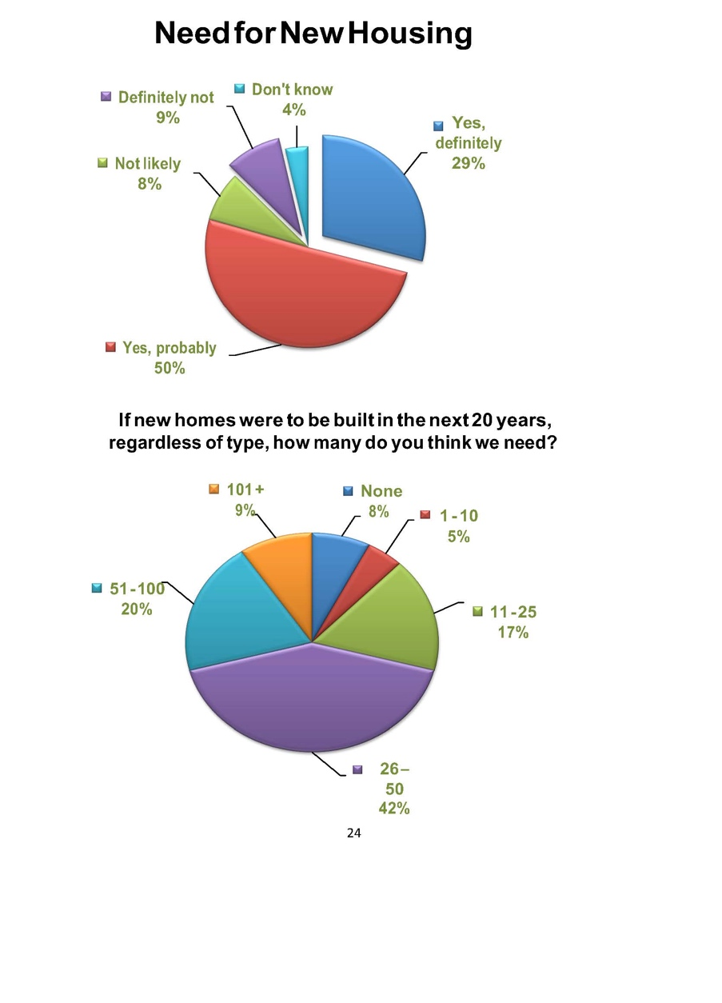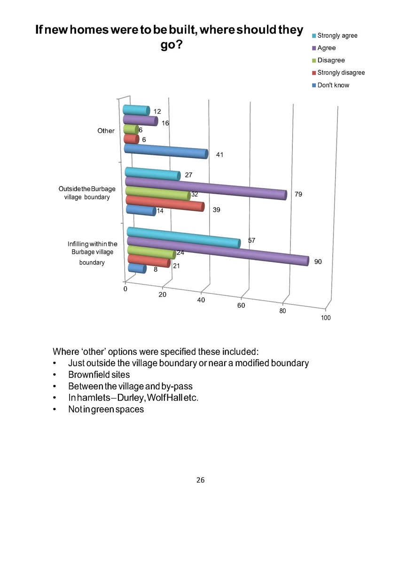
Appendix 2 Extract from initial village survey

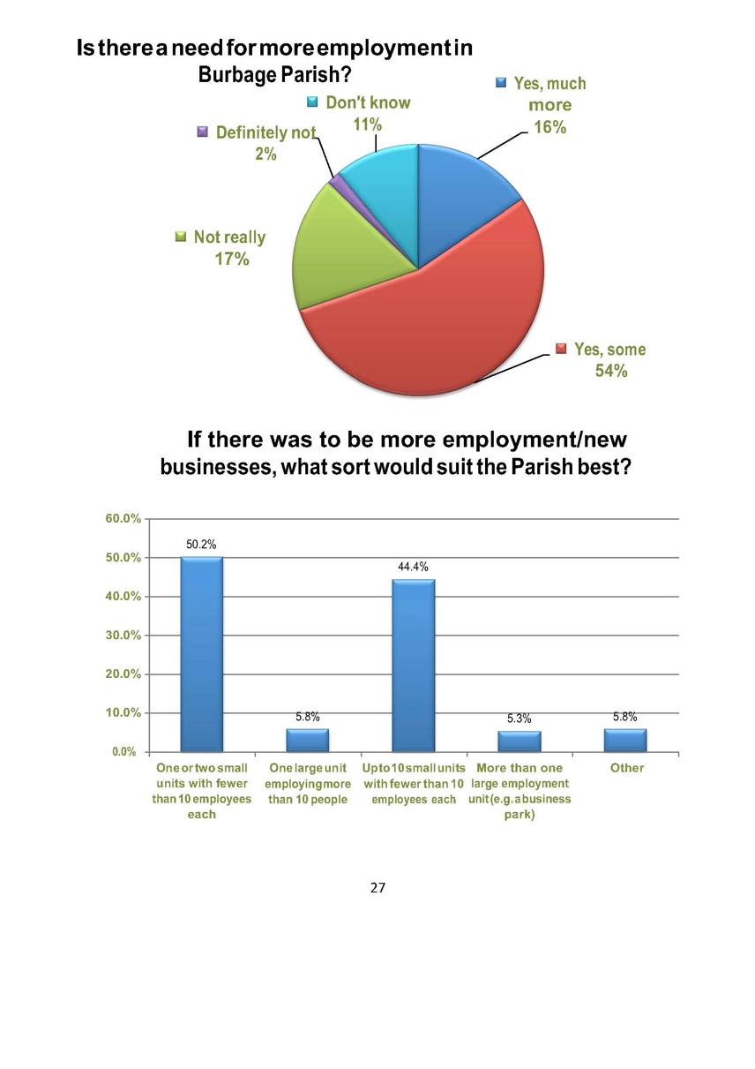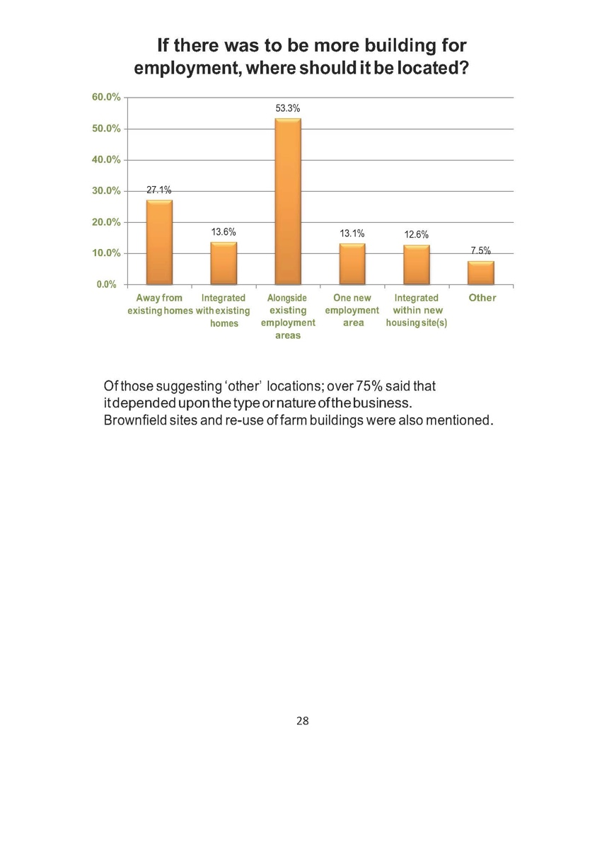

Appendix 2 Extract from initial village survey

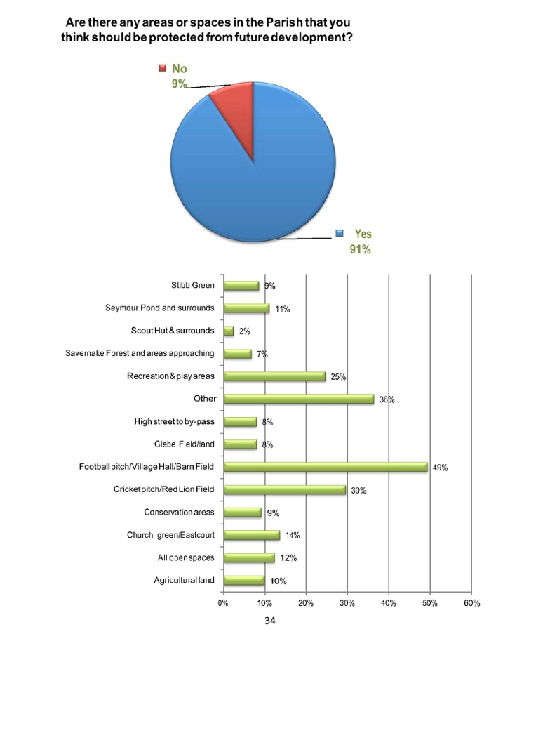

Appendix 3 Original overall site master maps – A. Sites in the village (Housing, Employment, Mixed)

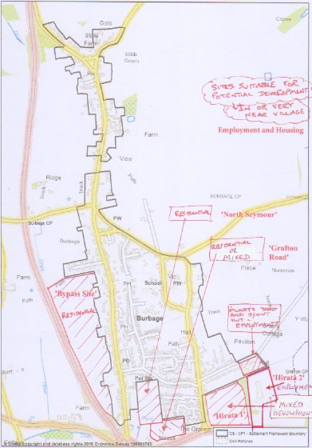

Appendix 3 Original overall site master maps – B. Sites outside the village (Housing, Employment, Mixed)

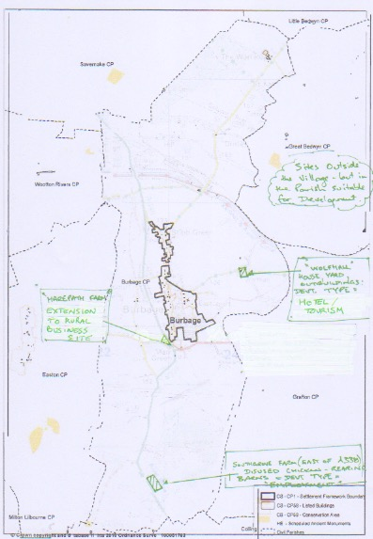

Appendix 3 Original overall site master maps – C. Local Green Spaces

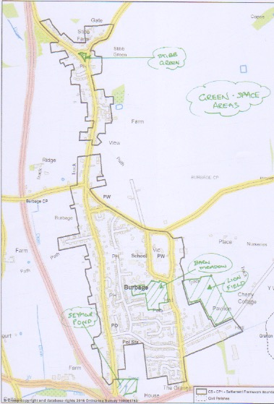

Appendix 4 Sites map – Sites to go forward to reg. 14 consultation

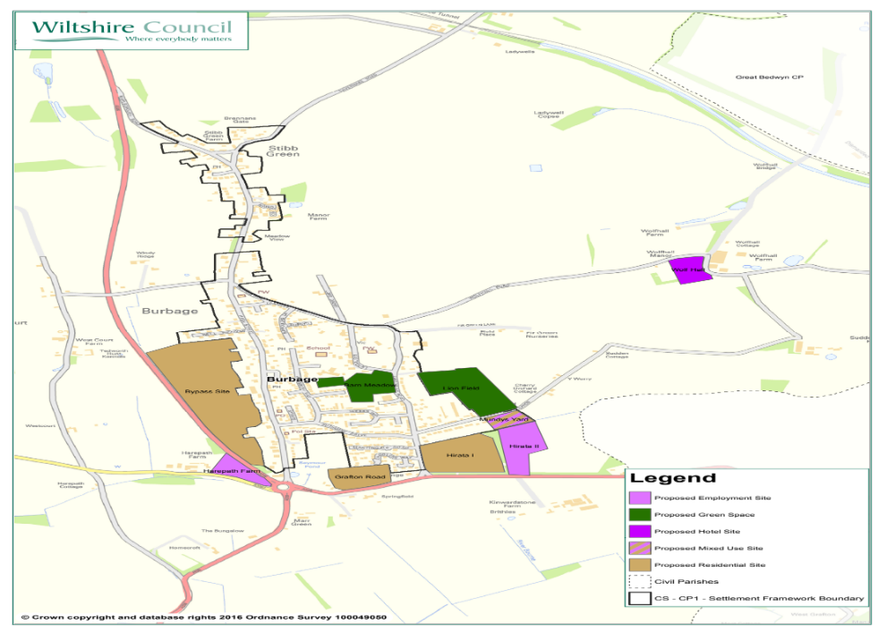

PlanningStreet 2016


