Burbage
Neighbourhood Development Plan
Burbage Parish 2014 - 2026

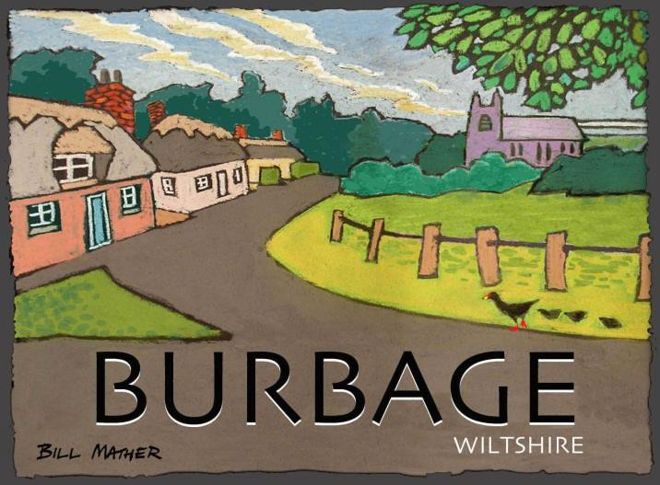

Regulation 14 Consultation Draft

Burbage Neighbourhood Development Plan

Contents

1.0 Introduction 5

The Burbage NDP has been prepared by the local community under powers granted by the Localism Act 2011.

The Neighbourhood Plan will sit alongside the Wiltshire Core Strategy as a part of the overall Development Plan for Wiltshire.

It will help guide and manage development in the Parish of Burbage until 2026.

2.0 Area Covered by the Plan 5

3.0 Evidence Base 5

4.0 Planning Policy Context 7

5.0 Physical Context 10

6.0 Vision of the Plan 17

7.0 Main Objectives of the Plan and non-land use aspirations 18

8.0 Policies of the Plan

20

Appendix 1 Evidence Base per Section

Appendix 2 Parish Map (Area of the Plan)

Appendix 3 Housing Needs Survey

Appendix 4 Burbage and the AONB

Appendix 5 Burbage and Heritage

Appendix 6 Burbage and Flood Risk

Appendix 7 Sites Map

Glossary of Terms

Acronym or Term | Definition
BNDP | Burbage Neighbourhood Development Plan
CA | Community Area
Community Engagement Survey | Initial community engagement survey of 2014
HRA | Habitat Regulations Assessment
LDF | Local Development Framework
LoD | Limit of development (e.g. village boundary)
LPA | Local Planning Authority (Wiltshire Council)
NDP | Neighbourhood Development Plan
NPPF | National Planning Policy Framework - 'The Framework' sets out planning policies for England and how they are expected to be applied. It provides guidance for local planning authorities and decision-takers, both in drawing up plans and making decisions about planning applications.
PC | Parish Council
Qualifying Body | Body authorised by law to create a Neighbourhood Plan. Normally the Parish Council.
Reg. 14 / 15 | Regulation 14 of the Neighbourhood Plan (General) Regulations 2012 requires that a formal 6-week Consultation be carried out. Regulation 15 Requires a Consultation Statement to be submitted.
SA | Sustainability Appraisal – A wide-ranging appraisal of the impacts of policy (such as this plan) to include socio-economic as well as environmental factors.
SEA | Strategic Environmental Assessment – European legislation requiring all plans to be assessed for environmental effects. In the UK compliance with the SEA Regulations can be achieved through SA or Sustainability Appraisal which takes into account socio-economic as well as environmental factors.
SHMA | Strategic Housing Market Assessment
VDS | Village Design Statement
WCS | Wiltshire Core Strategy

1.0 Introduction

1.0 The Localism Act invites communities led by a ‘Qualifying Body’, usually the local Parish Council (PC), to write Neighbourhood Development Plans (NDPs). Such plans set out how communities want their area to be developed over a given period; for Burbage, the NDP’s plan timeframe is the same as the Wiltshire Core Strategy, running to 2026.

1.1 In 2013 Burbage Parish Council approved the setting up of an NDP Working Group under
the chairmanship of Martin Cook. The Working Group is responsible for drafting the NDP.

1.2 In an initial community engagement survey in 2014, 85% of respondents supported the creation of a Neighbourhood Plan. The same proportion felt that this should cover the entire Parish and not just the main village (see Survey analysis given in Consultation Statement).

2.0 Area Covered by Plan

2.0 The whole Parish of Burbage is embraced by this NDP and is considered appropriate for designation as a Neighbourhood Area because:

- Burbage PC is a properly elected democratic body representing the entire local community within the Parish and is committed to ensuring the community’s views are fully reflected in future local planning decisions within the Parish
- Designation of the whole parish will ensure that the Plan will take into account planning issues relating not only to Burbage village but also smaller communities including Durley and the area near Southgrove Farm
- It is a properly constituted, well recognised and clearly defined Parish area and is entirely within the remit of the Parish Council
- Community consultation has endorsed this area for designation.

3.0 Evidence Base

3.0 In addition to information contained within the NDP itself, the evidence base for the NDP includes four supporting documents: the SA Scoping Report, the SA Environmental Report, the Site Selection Report, and the Consultation Statement. These contain research (documents read and absorbed, comments of consultees), site based assessment and inputs from the community.

3.1 In the case of the Burbage NDP, the SA Scoping Report began as a simple NDP Scoping and Research Report – in the early days before it was confirmed that an SEA would be needed. Into this report was condensed all of the documentary research and statutory consultee responses that were received during the initial research into the plan (some 18 months’ work). Once it was confirmed by the LPA that an SEA would be required (Screening completed in September 2014), it was decided to adopt the more comprehensive SA model (as the plan deals with more than just environmental issues). This report therefore provides a record of some of the detailed research undertaken to:

- Identify Issues and problems
- Take account of other plans, programmes and policies and understand the context they provided
- Consider the actions needed to correct the problems and tackle the issues as a basis for policy making.
- Create a set of Sustainability Objectives that all policies should contribute towards.

3.2 The SA Scoping Report therefore provides an account of some of the evidence base for the plan. In addition to that, the input of the community and those stakeholders consulted throughout were also critical and their comments also effectively are part of the evidence foundation of the NDP. These records can be found in the Consultation Statement.

3.3 The SA Environmental Report will test the environmental credentials of the plan and its proposals before the first Regulation 14 Consultation and will be revised thereafter if necessary. The Site Selection Report (given as Appendix 7) considers the land use planning issues regarding proposed sites and the Consultation Statement records community inputs into the overall process.

3.4 However, in themselves these documents do not show how research led directly to and then underpinned the Vision, Objectives and Plan policies. Simply quoting documents in an appendix does not seem enough to demonstrate a clear linkage. There needs to be some way of indicating directly how a certain piece of evidence led to a particular element of the Plan.

3.5 While each policy begins with a text box listing references to; ‘Plan Objectives, the NPPF and the WCS’ – to give an indication of links to these key aspects of evidence, the Burbage NDP goes further. Each of the main parts of the Plan is followed by a section entitled: “Evidence Base” and another marked, “Justification”. These sections give a brief summary of underlying evidence and the reasoning behind each item or policy.

3.6 Further detail is provided by the Evidence Base list, given as Appendix 2, which is divided into these sections:

  - Creating the Plan
  - Vision
  - Objectives
  - Policies

In this way, although it does entail some repetition, it is possible to monitor at a glance exactly what evidence foundations each aspect of the plan has. This is important, not only to satisfy an examiner and to reflect good practice in planning, but also as a key quality control tool that has been useful to the team in putting together the NDP – cross referencing and feeding back into the polices as they grew.

3.7 Finally, in order to provide the reader with an initial overview of both the Policy and Physical contexts, and to lead thereby naturally into the policies of the plan, the next two sections are essentially summaries of the evidence base that deal with these two critical cornerstones.

4.0 Planning Policy Context

4.0 The planning context for the NDP begins with Legislation and Regulations, including the Town and Country Planning Act 1990 (as amended), the Planning and Compulsory Planning Act 2004, The Localism Act 2011, the Neighbourhood Planning (General) Regulations 2012 and the Environmental Assessment of Plans and Programmes Regulations 2004. In addition to legislation and regulations, the Government has provided National Planning Policy Framework and Planning Practice Guidance (online resource) published by the DCLG.

4.1 The National Planning Policy Framework (NPPF) has much to say that is relevant to the Burbage NDP. The NPPF indicates that Neighbourhood Plans, ‘give communities direct power to develop a shared vision for their neighbourhood and deliver the sustainable development they need.’ It also makes it clear that, while Neighbourhood Plans must be ‘in general conformity’ with the development plan and take forward its strategic policies, outside of this limitation, they are free to ‘shape and direct sustainable development in their area.’ These plans, it makes clear, should be backed by a ‘proportionate evidence base’.

4.2 The NPPF sets out principles governing a number of key areas of the Burbage Neighbourhood Plan including the following which have been especially informative for the NDP:

- Nature, quantity and type of housing (47-55)
- Promotion of Mixed Use Developments (38)
- Use of Brownfield Land (111)
- Design Standards (58)
- Protecting the AONB (117/8)
- Conserving and enhancing Heritage (137/38)
- Planning for flood risk (99/100)
- Conserving biodiversity (117/8)
- Preserving green infrastructure (74)
- Designating Green Space (76/77)
- Ensuring viability and deliverability of sites (173)
- Encouragement of sustainable transport (29-41)
- Employment and jobs in rural areas (28)

4.3 In terms of the Development Plan, this consists of the Wiltshire Core Strategy (2015) plus saved polices of the Kennet Local Plan (2003). In 2008 a Conservation Area Character Appraisal was published with the aim of recording and protecting local distinctiveness and heritage. This has been adopted by the local planning authority and is a material consideration for development management purposes.

4.4 The Wiltshire Core Strategy (WCS) places Burbage in the category of ‘Large Village’. Large Villages are defined as settlements with a limited range of employment, services and facilities. Development in Large Villages will be limited to that needed to help meet the housing needs of settlements and to improve employment opportunities, services and facilities. Within the limits of development, there is a presumption in favour of sustainable development.

4.5 In other words, development should be of a moderate scale, reflecting the range of services and facilities available, and the most favoured location for this growth is within the limits of development – i.e. the village boundary. However, the NPPF stresses the need for flexibility in plan making (paragraph 14) and states that neighbourhood plans should (paragraph 16); ‘plan positively to support local development, shaping and directing development in their area that is outside the strategic elements of the Local Plan’. This is taken to mean that selected development outside the limits of development is acceptable subject to a robust site selection process, the support of the local community and the scheme being able to deliver sustainable development in terms of environmental impacts and other policies in both NPPF and the Development Plan.

4.6 The WCS has designated nearby Pewsey as the Local Service Centre and the strategy is for most development within the Pewsey Community Area to take place there. Burbage is not expected to absorb significant levels of development between now and 2026. However, the village does still provide a range of services for the surrounding rural area including Doctors Surgery, primary school, petrol station, convenience store and Post Office. These facilities and services are much valued by the local community as they keep Burbage alive and greatly improve quality of life, especially for those who find travel difficult due to age or health.

4.7 The WCS (e.g. policy CP18) stresses the need for development in the Community Area to respect the high value placed on the rural landscape and especially the AONB. The Core Strategy (CP41) also promotes low carbon construction and low-energy buildings, sets a policy context (CP’s 43,44,45) for housing which states that homes should provide for the entire range of needs and has policies that encourage the retention of rural businesses and services (CP’s 48 and 49). As one would expect with a strategic document of this nature, the WCS also has polices requiring the protection of biodiversity (CP 50), the historic environment (CP58) and air quality (CP55) as well as governing the management of flood risk (CP67). It sets out a policy promoting sustainable transport, tourism (CP’s 39, 40) and the protection of employment land (CP35). It also requires (CP52) development to retain and enhance Green Infrastructure such as sports fields, open spaces, woods, gardens and rights of way.

4.8 Some policies of the old Kennet Local Plan (pre Wiltshire Core Strategy) have been saved and carried forward. All were considered, however the most relevant for the NDP were felt to be:

  - Design: PD1
  - Housing and Use of Land: HC1-7, HC22, HC26, HC29 HC33
  - Employment: ED8,9,10. ED 12,13, ED28, 29.
  - Countryside, Landscape and Biodiversity: NR4, NR6, NR7, NR19, TR20
  - Heritage: HH1, HH10
  - Parking Standards: AT9
  - Developer Contributions: AT10.

NDP policies were checked against these polices and those of the WCS.

4.9 The existing Conservation Area Character Appraisal was formally adopted by the then LPA, Kennet District Council, in February 2008. It remains a material consideration in the determination of planning applications. The Character Appraisal also includes management proposals. The NDP takes forward the concerns and issues of the Character Appraisal and the Management Proposals. in particular, the following were influential:

- The description of Burbage as growing from a linear settlement with several distinct ‘Character Areas’ based on historic hamlets and modern building.
- The importance of the landscape setting, the canal and vernacular buildings, including the more than 40 which are Listed.
- The low overall density of development
- The importance of Green spaces, mature trees, green verges and hedges
- The views and vistas from the conservation area that emphasise roominess and space, even in an urban setting.
- The mixed architectural styles, traditional materials and structures, including some that detract from the quality of the village.
- The importance of hamlets and isolated farmhouses in the area surrounding Burbage
- Issues and problems including the number of overhead wires
- Presumption against developing open spaces including land south of old bakery.
- Need for high quality design in the Conservation Area (together with design requirements)
- The existence of archaeology Zone Maps
- A List of possible enhancements of the public realm.

4.10 The broad aim of the NDP is to take forward, interpret and add detail to this policy framework in ways that have community support. This will add certainty for both developers and the local community and, as the policy framework has already been subjected to extensive SA, help ensure that the development encouraged by the NDP will be sustainable.

5.0 Physical, Social and Economic Contexts

5.0 The physical context, environment and development constraints are explored more fully in the SA Scoping Report and SA Environmental Report. The following therefore is an overview of the physical layout and social characteristics of the village.

5.1 Burbage Parish is set in an area of distinctly rural character nestled in the North Wessex Downs AONB. The main purpose of the AONB designation is to conserve and maintain the natural landscape, enhancing its unique beauty; with a secondary aim of meeting the needs of those who live and work there.

5.2 The Parish starts at Warren Farm in the north and stretches in a southerly direction to Southgrove Farm on the border with Collingbourne Kingston Parish, includes more than just the village. The western boundary is designated by the hamlet of Ram Alley, Bowden Farm and Goldenlands Farm stretching east to the boundary of Tottenham House Deer Park, enclosing Wolf Hall Farm and heading south to the edge of Southgrove Copse.

5.3 The parish lies towards the eastern end of the Vale of Pewsey and Pewsey Downs, a very fertile region which acts as the catchment area for the Salisbury Avon although no river actually runs west-east. The vale runs between chalk downs rising in places to 289 metres. To the east of Burbage, the Kennet valley cuts through the Downs so that effectively Burbage lies on a connecting ridge of higher ground about 11 miles wide with the Marlborough Downs to the north and the Hampshire Downs to the south.

5.4 The northern edge of the Parish boundary crosses into the Savernake Estate, including the ancient Savernake Forest, a former royal hunting park. The setting of the settlement in this landscape makes a key contribution to the character and appearance of the conservation area, the forest of Savernake and the surrounding agricultural environment directly contribute to the rural flavour of the area. To the west of leaving a parcel of land that does little to contribute towards the character of the village.

5.5 Geologically much of Burbage lies on the tongue of greensand which extends east from Pewsey Vale. Chalk overlies the greensand to the south of the village and north of the canal the chalk sequence returns with deposits of clay-with-flints. Soils vary from the thinner soils overlying chalk to deep, rich, loamy but still well-drained soils of the valleys. Both types are valuable to agriculture; mainly arable on the chalk and a mixture of uses including vegetable growing on the heavier valley soils.

5.6 Heritage is an important issue in the village. Burbage, lying on the north-south route of the Marlborough to Salisbury road where it crosses the Vale of Pewsey, was first designated a conservation area in 1993 in recognition of its architectural and historic character. However, it is a linear settlement which has evolved from several hamlets on the periphery of the Savernake estate. Consequently, it does not have a uniform character, but rather areas of quite different appearance and atmosphere within the overall built environment, strung out along and aside the High Street (over a mile long) which runs from Stibb Green in the North to Marr Green in the South.

5.7 While the ages of property along the High Street itself span several centuries, from modern brick houses to timbered and thatched cottages, the east and southeast parts of the village are more dominated by developments of the twentieth century.

5.8 There are 73 Listed Buildings in Burbage. Despite this, seen overall, it could be said that the village lacks a cohesive architectural style. It is more accurate to say that it contains a mixture of old and new buildings, but with character ‘hotspots’ of higher quality, based around the historic cores of the former hamlets of which the village is composed. Nevertheless, the older ‘character’ buildings are much valued by the community.

5.9 In addition to historic buildings, the Kennet and Avon Canal (opened 1810) north of the village provides a strong landscape feature and working record of the local industrial past. The village church was founded in the twelfth century and the village slowly grew during the middle-ages. Far older artefacts have been found locally, including stone weapons. Given the length of occupation, and the location including favourable climate and soils, it is likely that the area contains a wealth of archaeology.

5.10 The published Conservation Area Appraisal describes the character of the older part of Burbage in some detail. However, the following can usefully be added here as a brief introduction. Firstly, the Conservation Area broadly follows the linear structure imposed by the High Street to the depth of the frontage buildings or a little beyond. This reflects the historic evolution of Burbage – the modern village having grown from the linking of earlier mediaeval settlements and dwellings by the road that is now the High Street. Put simply, most of the older properties are either along the High Street or are related to it in the form of sub settlements (formerly separate hamlets) clustered just off it.

5.11 The High Street itself is largely characterised by high banks bordered by mature trees and hedgerows; these narrow enclosed areas are however interspersed with wide open zones. The essential pattern of buildings in the High Street is created by widely spaced, set back frontage buildings set in their own grounds. This form of development contrasts markedly with the housing estates built in the village during the latter half of the twentieth century – mainly to the east. These large scale developments leak through upon the more traditional appearance of the High Street in the form of large, open visibility splays at the various road junctions.

The Layout of Burbage Village

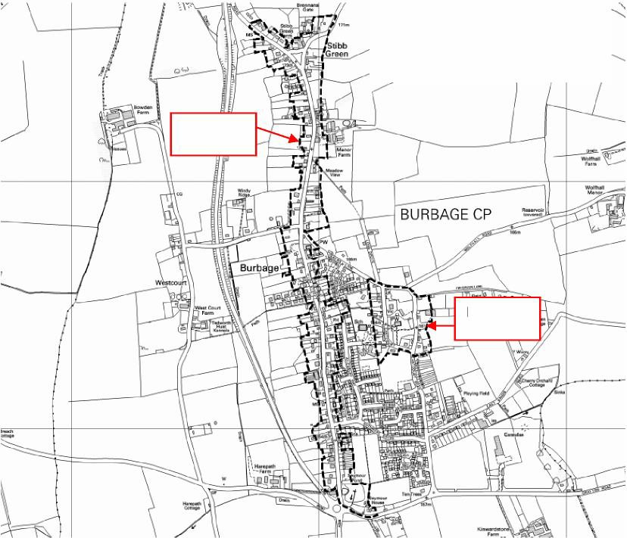

High Street

Eastcourt

© Crown copyright. All rights reserved. Kennet District Council, Licence No.100017656, 2008

5.12 The North Wessex Downs AONB Management Plan runs from 2014-2019. In addition, to providing a useful description of the AONB (the setting for Burbage) it also contains proposals to assist in the management of the area, not only for the countryside and biodiversity, but also for the communities that live and work there.

The Management Plan has been useful because it provides an accurate description of Burbage’s surroundings and summary of character and explains why key aspects of them are important;

- Pattern of villages and isolated farms within quiet countryside and patches of woodland
- Views of scarps and valleys, openness of the downs, the enclosure of the forest,
- Low density of human population
- Instances of beneficial interaction between human activity and nature (buildings and agriculture)
- Habitats; their locations and importance, the need to maintain and expand them and enhance connectivity
- History, archaeology and implications for development
- Water and water resources
- Preference for new housing on brownfield land within settlements
- Small scale developments on village edge may be acceptable where there is local need
- Overdevelopment by infilling
- Green tourism may be acceptable subject to impacts
- Need to conserve water use and manage drainage
- Need to enhance Green infrastructure
- Need for landscape assessment for significant development
- Support for improved broadband
- Support for sustainable transport enhancement, including PROW
- Dark skies and tranquility

5.13 At the European level, the EU Biodiversity Strategy 5 was adopted in May 2011 in order to deliver an established new Europe-wide target to ‘halt the loss of biodiversity and the degradation of ecosystem services in the EU by 2020’. The Wiltshire Biodiversity Action Plan (shortly to be supplemented by a new Wiltshire and Swindon Landscape Conservation Framework) identifies the area Burbage lies within as being rich in quality habitat and species. In particular Savernake Forest, part of which lies within the Parish, is one of the largest woods in Wiltshire, and contains important species of plants, fungi and invertebrates. Birds include Wood Warblers, Turtle Dove and Woodcock, as well as Tree Pipits and Spotted Flycatcher. Mammals include Dormice and bats (including Barbastelle Bats). The BAP sets out Action Plans for a range of Habitats including those within the Plan area.

5.14 Burbage is located within the River Avon Special Area of Conservation (SAC) and is also covered by the Salisbury Plain SAC. This means that the area contains sensitive and important biodiversity interests and that extra attention needs to be paid to development that could possibly affect the catchment area by the pollution of watercourses. Development has the potential to mitigate negative effects or to actually positively enhance habitat.

5.15 The NDP was fully screened under HRA Regulations in September 2016. This found that the NDP will have no likely significant effect on any European designated sites. However, if further changes are made to the Plan, the HRA would need to be updated. The HRA Report can be seen as an Appendix in the SA Report. The initial community engagement did not indicate any local priorities or concerns. In responding to the Scoping Consultation, English Nature was most concerned with landscape impacts, given the fact that the Parish is washed over by the AONB.

5.16 The Burbage NDP relies on the same flood-risk and climate change evidence as does the WCS – namely the Wiltshire Council Strategic Flood Risk Assessment SFRA carried out in 2008 /9 and updated in 2013 and the UK Climate Projections (2009). The key points of the SFRA for the Burbage NDP are:

The most significant type of flood risks in the area are:

- River flooding
- Flooding from the Kennet and Avon Canal
- Water run-off flooding (this is the most likely risk)
- Overall flood risk in Burbage itself is, however, low (i.e. the village itself lies in Flood Zone 1, as does most of the Parish).
- The River Bourne has its source south of Burbage but flows south- away from the village.
- There are some land drains / streams in and around the village and a few ponds
- The Flood Risk Map (Appendix 6) – should be used as an advisory tool.

5.17 Additionally;

  - Site selection and development design should seek to reduce flood risk to new and existing properties
  - An important aspect of reducing flood risk locally is likely to be SUDS as this can slow down run-off
  - Climate change will worsen all present flood risks
  - There are water Source Protection Zones within the Parish
  - It is important to protect such water source areas from pollution.

5.18 Given the fact that local flood risk is low and that climate change measures relating to development (such as SuDS) are already contained within higher level policy such as the NPPF and the Wiltshire Core Strategy, it is not proposed to include specific policies in the NDP requiring any additional local measures. Having said this, proposals for development that pay high regard to minimising carbon emissions or mitigating the expected effects of climate change, will be viewed favourably, subject to compliance with other polices of the plan.

5.19 Population (from HNS and Census)
Burbage has a population of 1,772 according to the 2011 Census, comprised of 728 households. There were approximately thirty more dwellings recorded in the parish in the 2011 than in the 2001 Census. The Pewsey Community Area as a whole is one of the least populous in Wiltshire, population density, based mainly in small villages and hamlets is low.

5.20 Deprivation
Overall, as shown by the Wiltshire JSA (based on 2011 Census data) Burbage has less deprivation than the South West or Wiltshire averages. However, within that wider picture, it is nevertheless true that Burbage remains a socially mixed village. It contains a mixture of properties from the relatively grand to the modest and everyday.

5.21 Age Structure
Pewsey Community Area (CA) has about the average population of younger people, fewer of working age and more of retirement age that the average for England. The retirement-age population increased by 520 persons to 3,350 persons, an increase of 18.4% from 2001 – 2011, although this was well below the Wiltshire average increase of 24.4%.

5.22 Health and Wellbeing
The Wiltshire (Joint Strategic Assessment (JSA) for Pewsey Community Area shows that the health of residents in the Area is above average for the South West. Female life expectancy in the Community Area is 2.7 years longer than the Wiltshire average (86.6 years compared to 83.9 years for Wiltshire). Male life expectancy is, however, around a year less than the Wiltshire average (79.5 years compared to 80.4 years for Wiltshire).

5.23 Overall, 86.8% of people in the Community Area said they were very satisfied, or satisfied with their lives compared to 82.6% in Wiltshire. However, the Area has a slightly higher rate of preventable mortality than the Wiltshire average, although still substantially better than the average for England. The latter point suggests that efforts still need to be made to encourage preventative action – for example increased use of recreation facilities for exercise.

5.24 Housing is a key element of the NDP and evidence of need was first obtained via a Housing Needs Survey (HNS) undertaken, at the Parish Council’s request, by Wiltshire Council as the Housing Authority in 2014. The report is given as Appendix 3. Information on local market conditions was obtained from the SHMA 2011.

5.25 The HNS indicated that the majority of residents who responded supported more housing in Burbage (85.7%). The most popular scale for development was between 21 and 40 homes. Of these, the survey found a demonstrable need for affordable housing of all types of around 17 units.

5.26 In terms of market housing, the survey also confirmed the anecdotal evidence of Steering Group members that affordability of homes was an issue for first time buyers who would otherwise have been likely to gain a mortgage. The survey showed that a typical 2-bedroom house in the village cost approximately £244,300. The Annual Survey of Hours and Earnings indicates that the gross annual median income of employed persons in the Kennet area in 2011 was only £21,712.

5.27 According to the SHMA, Burbage is located within the ‘East’ Housing Market Area. This is an area that looks east towards London and the south east. Demand for housing is strong, especially from east-bound commuters. The area is experiencing net in-migration and is becoming perceived as an affordable and attractive alternative to locations closer to London, thanks both to lower prices and attractive countryside.

5.28 The location and sustainability of Burbage is generally considered to be good in terms of self-containment, especially for a settlement of moderate size, with numerous facilities available locally including a doctor’s surgery, 2 pubs, a village shop, a school, a service station, playing fields, a village hall and numerous sporting and other clubs to name a few. These facilities and services are much valued by the local community as they keep Burbage alive and greatly improve quality of life, especially for those who find travel difficult due to age or health

5.29 However, there is a shortage of employment possibilities locally. The HNS provided the following interesting data.

Persons in household | Distance to work
Persons in household | Up to 2 miles | 2 - 10 miles | 10 - 50 miles | 50 miles + | Total
Person 1 | 32 | 42 | 82 | 22 | 178
Person 2 | 24 | 37 | 31 | 18 | 110
Person 3 | 2 | 9 | 2 | 1 | 14
Person 4 | 0 | 2 | 1 | 0 | 3
Person 5 | 0 | 0 | 0 | 0 | 0
Total | 58 | 90 | 116 | 41 | 305

5.30 The HNS states:
“These results suggest a mixed level of sustainability for new housing development in Burbage, indicated by the survey respondents. While 48.5% of households’ working members usually travel less than ten miles to their place of work, 51.5% travel more than that, suggesting a potential lack of more local sources of employment”.

5.31 This conclusion was supported by the first Community Survey, where 70% of respondents wanted more employment opportunities within the village. Numerous small employers were preferred rather than one or two major developments. While some uses were felt to be better on separate sites, low-impact businesses were felt to be able to co-exist with housing. As such, mixed-use development is a possible way forward. There is also an appetite for improved shops and services located centrally – possibly in the High Street.

5.32 The existing employment base is varied, however three sectors that could be developed (thanks principally to location but also to feedback from the community engagement Survey) are:

- Tourism (Savernake Forest and the AONB)
- Services (especially self-employment and working from home)
- Agricultural diversification (the village already contains one farm shop).

There is a strong desire to retain and enhance employment opportunities for all age groups. Many older residents are active and wish to continue to be able to work, while for younger residents, local employment would reduce the need to travel.

5.33 Transport
Despite being by-passed by the A346, traffic volumes and excessive speeds were themes of early community consultation responses. However, accident statistics (JSA) show that the area actually has a lower accident injury rate than the Wiltshire average. Similarly traffic flows are below average and have remained relatively constant since 2008.

Community consultation identified the following issues as being locally significant:

- Poor bus services
- Parking problems
- Noise from the by-pass

There is support for enhancement of local employment, retail and other facilities to reduce the need to travel outside the village.

5.34 Leisure and recreation
Burbage has numerous clubs and societies and many residents have a keen interest in sport and informal recreation. The village is blessed with a number of green spaces, including:

- The football and cricket pitches
- The Village Hall
- Stibb Green
- Church Green / East Court

5.35 There is a strong desire in the village to protect these green spaces from development and if possible to enhance their quality and facilities. Not only do these spaces offer facilities for both formal and informal recreation, they also help to retain an open and natural feel to Burbage, offering a welcome contrast to the more built up parts.

6.0 Vision of the Plan

6.0 The vision of the plan has been developed from public consultation including participatory public meetings, a full Parish Household Survey, a Business Networking Seminar and participation in established community events and activities. It has also been constructed to tackle the issues and problems identified in the SA Scoping Report.

6.1 The vision of the plan is:

Burbage will flourish as a living, working village. Any future development in Burbage Parish should support the local economy, provide high quality accommodation for all our community and respect the individual character of where we live, especially in protecting our natural environment and valued green spaces.

The vitality of the village will be enhanced, and new housing will be matched by suitable employment opportunities and infrastructure capable of supporting this development.
The Parish wishes to reduce its carbon footprint by encouraging greater use of local amenities, thus reducing the need to travel away from the village whilst promoting healthy life styles, well-being and an improved physical and social environment.

The BNDP intends to ensure that the local community has a powerful voice in managing future change in the village and in particular a greater say in where, how, what and when development occurs.

6.2 Evidence Base
Consultation: Inputs from Community Engagement including the Survey
Documentary: All in Evidence Base

6.3 Justification
The Vision encapsulates the wishes of the community, includes all of the most important issues identified in research and consultation and is intended to provide both a focus for the NDO and clarity for developers. It is consistent with the NPPF and the WCS

7.0 Main Objectives of the Plan

7.0 Following the community consultation exercises and in association with Parish Council Policies, the main Planning Objectives of the Burbage Parish Neighbourhood Plan are designed to take forward the Vision; identifying key aims that policy will address. These Planning Objectives have been tested against the environmental Objectives (the ‘SA Framework’) established in the Sustainability Appraisal Scoping Report. This testing is given in the full SA Environmental Report and will examine the environmental suitability of the Plan Objectives and assess whether they are likely to result in ‘Sustainable Development’. Plan policies will also be subject to the same testing.

7.1 The NDP Objectives are:

- To deliver the types of housing and employment needed to sustain the village
- To steer development to the most sustainable locations (preferably brownfield) likely to receive community support
- To balance new housing with employment using mixed-use developments if possible
- To encourage suitable economic activity and employment, including tourism and agricultural diversification, maintaining and expanding local services and facilities, especially those for young people, in order to improve the self-containment of Burbage and so reduce the need to travel
- To ensure that the community benefits from new development and to specify main village needs. New development should be matched by necessary infrastructure and development and CIL monies should be used to fill existing infrastructure gaps and to upgrade ageing facilities (such as the village hall) or improve deficiencies.
- To encourage healthy lifestyles, reduce car use and improve sustainable transport infrastructure such as paths, crossings and bus services.
- To protect and if possible enhance the recreational green spaces of the Parish, linking them into a green network of paths and cycle ways and improving the habitat value of landscaping.
- To protect the quality, character and local distinctiveness of the natural and historic landscape and village buildings, and maintain high design quality, especially within the conservation area
- To protect and enhance public off–road parking by the creation of a limited number and scale of new facilities. To mitigate negative effects of any new off-road public parking by means of landscaping, SuDS and tree planting as appropriate.

7.2 Evidence Base
Consultation: Inputs from Community Engagement including the Survey
Documentary: All in Evidence Base, especially Scoping Report

7.3 Justification
The Objectives stem directly from identified issues and problems (e.g. as set out in the SA Scoping Report). They summarise what the plan aims to achieve in general and They help give focus to policy creation and form an agreed set of principles underpinning the plan. They are not intended to represent a set of Objectives to deal with all issues facing the community, not least because some of these (e.g. Climate Change) are already covered by relevant policies elsewhere.

7.4 Non-land-use aspirations are:
Although not forming part of the formal land use policies of this Plan, the following matters are aspirational aims for future community action.

- To enhance community involvement in local planning
- Traffic- calming measures; especially along the High Street
- Gritting of pavements in winter and general street maintenance

7.5 Evidence Base
Consultation: Community Engagement Survey
Documentary: None

7.6 Justification
Some issues raised in the consultation process are not suitable for inclusion in the plan, generally because they do not relate precisely to land-use issues. However, there seems to be no logical reason why, in addition to its binding Development Plan policies, the NDP cannot also act as a focus for informal local action by identifying and agreeing priorities for non-plan action.

8.0 Policies of the Plan

8.0 This section of the Plan contains the policies that, together with the WCS and the Framework, will manage development in the area until 2026. These Policies are intended to help deliver the plan’s Vision and Objectives. The policies have been informed by both the public consultation (especially the initial Survey) and are consistent with the WCS, saved policies of the KLP and the NPPF. In order to make links with higher levels of policy clear, each policy in the plan is preceded by a section detailing the various policy connections. Following each policy a section provides additional justification.

Policy 1 – Development Strategy

8.1 The community recognises that as a Large Village, there is a need for some development - both residential and employment - in the Parish to maintain the viability of local businesses and to stimulate the continued vitality of the local area and to deliver the development foreseen by the WCS. The latter was relatively modest in scale, the Pewsey Community Area as a whole being envisaged to deliver only some 137 homes, and most of those in Pewsey. Core Policy 18 defines Burbage as a Large Village, within which modest development – primarily within the LOD is acceptable.

8.2 However, the plan has a positive attitude towards controlled growth and is not in the business of saying an automatic ‘no’ to development, or of applying an arbitrary limit on housing numbers. Instead it seeks to direct and control it in the interests of sustainability, the wishes of the community and the provision of infrastructure for the benefit of the village. The Plan reflects the fact that the WCS figures were expressed as minima. While the Plan accepts that development greater than the minima is needed in order to achieve the objectives of the plan, this does not mean that large scale housing developments (totaling more than 60 dwellings over the plan period) are anticipated or welcomed.

8.3 During Community engagement 79% of respondents mentioned a need for at least some additional housing in the Parish, with only 14% declaring they see no need for additional housing. The Wiltshire Council Housing Needs Survey recommends 17 houses are urgently required to meet current need for either subsidised rented housing or shared/low cost home ownership.

8.4 This strategic policy therefore sets out a positive but carefully controlled attitude toward moderate-scale development that could improve the critical mass of Burbage, help safeguard the vitality of businesses and services and deliver needed infrastructure benefits, yet which will not compromise environmental quality or assets valued by the community.

8.5 The majority of respondents (147 or 73%) during initial consultation were in favour of housing development within the existing village boundary as defined by the LoD (Limit of Development). A further 106 respondents however suggested development outside the LoD. Many respondents indicated a desire to preserve the open countryside of the village’s setting, especially where this was of high quality. This Policy therefore includes sites of both types, though with some caveats.

8.6 While accepting of moderate quantities of development, in appropriate locations, there is a strong desire in the community to preserve existing green spaces within the village in particular those used for formal and informal recreation.

8.7 The overall approach can be summarised as accommodating modest change within the village boundary on brownfield sites, while preserving character and valued open spaces. At the same time, development of a scheme or schemes, including those of larger scale (e.g. over 25 units) will be permitted outside the LOD on the land indicated where this can be achieved with acceptable impacts on neighbouring properties, without significant damage to the rural setting. Large scale development (over 25 units), in any location, will be expected to make a contribution towards village infrastructure and in particular the provision of a new village hall.

8.8 Notwithstanding the above, wherever it is located, there is a need and desire to balance further growth of housing with employment possibilities. Since the development of stand-alone employment facilities are not always commercially viable, proposals for mixed-use schemes incorporating housing and B1, B2 or retail uses will be considered favourably subject to compliance with other plan policies.

8.9 While most development will take place in Burbage, the community does not want smaller rural settlements in the Parish to stagnate in a 'sustainability trap', where no development at all is permitted. Accordingly, while the bulk of development in the Community Area must take place in Burbage, very limited development will be permitted in the outlying hamlets.

8.10 There is a desire in the village for housing to meet the needs of all sections of the community. In particular, all developments should include, where practicable, 1 and 2-bedroom starter homes. Additionally, subject to compliance with other polices of the plan, schemes that provide for a variety of tenures will be treated favourably.

Policy 1 – Development Strategy

Context | References
Burbage NDP Objectives | 1, 2, 3, 4
Wiltshire Core Strategy | CP1, CP2, CP18, CP48, CP51
NPPF | Paragraphs 7, 17, 28, 37-38, 47‐55, 183‐185

Policy 1 - Development Strategy
a. Within the Limits of Development (LoD) of Burbage, development will only be permitted
on brownfield sites or those identified in this plan unless it can be demonstrated that
these possibilities are unsuitable or unavailable.
b. Other than sites identified in this plan, residential development outside the LoD will be
acceptable only in exceptional circumstances. Applicants would have to demonstrate a
lack of available sites within the village and show that no significant negative impact
would occur in the AONB.
c. Mixed-use developments including housing and retail or B1 and B2 industrial
employment uses are encouraged and will receive favourable consideration subject to
compliance with other policies of the plan.
d. In all developments of greater than 5 units a proportion of homes should be aimed at
first-time buyers. For the purposes of this policy, this means one and two bedroom
dwellings.
e. Development in the hamlets and outer small settlements of the Parish area will
normally be limited to the conversion or extension of existing buildings and will be
modest in scale. However, adjacent to existing rural ‘parent’ dwellings or farms,
development of single dwellings or modest employment facilities such as
workshops, in addition or instead of conversion, may be acceptable providing such
schemes are to meet local needs for homes and employment and comply with other
policies of the Plan. In these cases, footprint of the new development must be smaller
than the existing ‘parent’ building and landscaping must be of high standard.

Note: Policy amended in light of SA to include better landscaping. See SA Appendix 8.

8.11 Evidence Base
Consultation: Community Engagement Survey
Documentary: Housing Needs Survey
Appendix: See also Appendix 1

8.12 Justification
This policy is the approach that the community has decided to support. It is intended to achieve the following planning objectives:

- To add local detail and interpretation to policies of the Wiltshire Core Strategy
- To provide more certainty for developers and residents
- To permit a level of development that will generate critical mass to support retail and other services in the town and which will enable contributions towards community infrastructure.
- To make the most efficient use of local land
- To protect the countryside and especially the AONB
- To permit limited, natural growth in the smaller hamlets and villages to prevent stagnation and allow all of the community to benefit from appropriate development
- To reduce the need to travel by encouraging the balancing of housing and employment.

POLICY 2 – Housing (General)

Context | References
Burbage NDP Objectives 1, 3, 4
Wiltshire Core Strategy 1, 2, 18, 45, 46
National Planning Policy Framework 28, 47-55

Policy 2 – Housing (General)
S
a. Any development of 4 or more houses must include at least 25% of the total number of
as 1 or 2 bedroom dwellings.
b. Developments for retirement housing will be looked on favourably, whether as stand-
alone or as elements of a larger scheme, subject to compliance with other policies of
the plan.
c. Development of 4 or more dwellings should include designs that facilitate working from
home (for example home offices or home office support hubs within the development).
d. Developments of more than 30 homes should include provision of at least one home
specifically design for disabled access or to facilitate care at home.

8.13 Feedback has been obtained by means of consultation exercises and the Wiltshire Council “Housing Needs Survey for Burbage” (February 2014). The findings of these separate exercises are similar. Both revealed a need for housing in all categories; social, affordable and open market. Of all respondents, 79% mention a need for at least some additional housing in the Parish. The Wiltshire Council Housing Needs Survey recommends 17 houses are urgently required to meet current need for either subsidised rented housing or shared/low cost home ownership. 7 of 8 Housing Needs Survey respondents not eligible for affordable housing stated it was not possible to meet their housing needs on the open market. The most needed housing unit (with 80.6% favourable response in the consultation) is the small, 1 or 2-bedroom property. This is also reflected by the high number of respondents looking for new housing (76.2%), affordable housing (80.52%) or retirement housing (64%) - all of which could be met by smaller housing units. The Housing Needs Survey also identifies immediate demand for 7 family size houses as well, so this Policy reflects mixed need.

The policy has been amended (d above) to include the recommendation made in the SA for inclusion of disabled access properties. This need was also revealed in the HNS.

8.14 Evidence Base
Consultation: Community Engagement Survey
Documentary: Housing needs Survey
Appendix: See also Appendix 1

8.15 Justification
The policy is designed to ensure:
- Appropriate housing opportunities are created for local people
- Homeworking is encouraged
- Life-long housing provision is available- housing suitable for a range of ages including elderly

Policy 3 – Housing and Mixed Use Sites

Context | References
Burbage NDP Objectives 1, 2, 3
Wiltshire Core Strategy 1, 2, 18, 45
National Planning Policy Framework 18, 28, 38, 47, 55, 123

Housing and Mixed Use Sites
a. Grafton Road - Housing Development of 15 homes of mixed size and type is
acceptable subject to:

- Satisfactory highway access
- Screening of existing properties to south

b. Mundy’s Yard and Scout Hut – Mixed Use, 20 Homes plus associated offices or
retail.

The proposal here is to re-locate the existing Scout Hut and Mundy’s builders yard
to other, better locations. Mundy’s would probably go to an all employment
location such as Hirata I. The Scout Hut could go to Barn Meadow or Red Lion
Field Local Green Sapces.

Subject to:

- Satisfactory re-location of existing Scout Hut / Mundy’s business
- modest element of employment use in replacement scheme
- Developer contributions towards scout hut

c. Bypass Site. Land between village and bypass. Housing Development of up to 80 homes with green spaces and habitat improvement. Subject to:

- incorporation of public green space / park
- habitat enhancement scheme
- adequate screening for existing properties to east
- linking to village by network of paths and cycle ways
- Adequate noise attenuation for new properties closest to by-pass.
- Replacement of existing Village Hall as part of the scheme
- creation of a master plan with community involvement to guide development.

d. Hirata I – Housing Development of up to 60 homes. Subject to:

- adequate screening for nearby properties
- Landscaping and design scheme to ensure views in and out of the and from the AONB are not compromised
- connection of site with village by means of foot and cycle path.

For Sites Map see Appendix 7. For site selection criteria see SSR.

8.16 Given its size as a Large village, the core strategy does not assume that Burbage will be subject to major housing growth. However, the NDP, while accepting the overall strategy of the WCS, is based on the idea that growth in housing, if properly channeled, is likely to result in a more sustainable settlement and one with a higher quality of life. The reason for this is that the village currently has gaps and weaknesses in its infrastructure and facilities, and development would provide the funds and critical mass necessary to upgrade this. The Plan therefore proposes several housing and mixed use sites in locations where they could be absorbed without significant environmental damage, and indeed where they are likely to create important planning benefits.

8.17 The sites selected are generally of some size, since it is also understood that larger, medium- sized schemes are able to provide more in the way of infrastructure contributions. This is relevant given the infrastructure priorities identified in Policy 4 (‘Developer Contributions’) which identifies the needs, including a new village hall.

8.18 However, while it is a legitimate aim to secure planning benefit from the community and while the area has generally good viability levels according the Wiltshire Council Viability Study, policies must not impose an unrealistic burden such that viability of schemes is jeopardised. This is particularly the case with mixed use schemes such as Mundy’s Yard / Scout Hut. In the case of mixed use developments therefore a viability assessment submitted by the developer could reduce, though not eliminate, the level of financial support provided.

8.19 In terms of the largest site, Bypass, the scale of the development in proportion to the village and the need to mitigate possible negative impacts requires that this be brought forward by means of a masterplan with significant community involvement. In order to ensure that development is encouraged towards the best available sites likely to get community support, the plan proposes the following housing and mixed use sites.

8.20 Evidence Base
Consultation: Community Engagement Survey
Documentary: Burbage Neighbourhood Plan Site Selection Report (SSR), Burbage Neighbourhood Plan Sustainability Appraisal (SA) Environmental Report.
Appendix:

8.21 Justification (General)
The sites proposed represent in total a greater quantity of housing than proposed by the Wiltshire
Core Strategy for Burbage. However, the figures in the Wiltshire Core Strategy are minima and the Strategy itself does acknowledge that villages can become more sustainable as they grow bigger. The rationale of the NDP is similar in that it assumes housing growth will create a greater critical mass to support services. Additionally, the NDP requires a significant quantity of housing in order to fund the infrastructure benefits that the community wants on the back of developer contributions.

8.22 Justification (Site Specific)

Rationale behind site selection is given in the separate Site Selection report (SSR).

a. Grafton Road – Logical extension of housing from recent Persimmon development. Well related to the village and screened from the outside landscape by mature trees.

b. Mundy’s Yard / Scout Hut – Possibility to relocate dust-generating use to a better site and also upgrade Scout Hut. Possibility to create some retail or office development as part of a mixed use scheme.

c. Bypass Site – edge of village site, well related to services. Poor land quality that could be upgraded and enhanced for landscape, biodiversity and recreation. Large enough to generate significant funding for new village hall.

d. Hirata I. Site well related to village and proposed employment site. Well screened and well related to road network. Could be linked to village by foot and cycle path.

Policy 4 – Developer Contributions

Context | References
Burbage NDP Objectives 5, 6
Wiltshire Core Strategy 3,
National Planning Policy Framework 17, 42, 184, 185

Developer Contributions
a. To replace or re-build the existing village hall
b. To improve sporting facilities
c. To establish a café or meeting place
d. To provide additional public off road parking as part of any development or at a suitable village centre site if one can be found. The aim is to reduce congestion and support local businesses (including tourism) by adding a small car park or car parks amounting to no more than 40 spaces.
e. To enhance local broadband services
f. To connect to or enhance sustainable transport modes, including foot
or cycle paths, bus services or infrastructure to facilitate any of these.
g. To plant new trees and landscaping especially along sustainable
transport links or in areas which would protect landscape from
development, or as avenues. Specimen trees in prime locations as
landmarks would also be welcomed.
h. To replace or upgrade the Scout Hut.

8.23 Developers may be required to contribute towards the provision of local infrastructure and to mitigate impacts of development proposals in order to make them acceptable in planning terms, in accordance with National and Core Strategy policy. This may include both CIL contributions and those made by section 106 agreement. The following policy identifies areas for priority investment as schemes come forward as expressed by the local community (for example in the initial Survey)

8.24 Evidence Base
Consultation: Community Engagement Survey
Documentary: Wiltshire Council Local Plan Viability Study 2014,
Appendix: See also Appendix 1

8.25 Justification
As it grows, the village requires investment in infrastructure to both regenerate existing services and facilities and to provide for new residents. It is considered to be fair that fresh development, especially that likely to place significant new demands on infrastructure should help to meet the infrastructure costs. At the same time, requirements should not be so onerous that they render schemes unviable. In Burbage the key areas where investment is needed are set out in the policy above.

Policy 5 – Economy (Business, Employment and Tourism)

Context | References
Burbage NDP Objectives 1, 3, 4
Wiltshire Core Strategy 34, 38, 39, 48, 49
National Planning Policy Framework 28

Economy: Business, Employment and Tourism – Generic Policies
a. Working from home and small workshops not likely to impact on the amenity of neighbours by virtue of operation including traffic generation will be permitted throughout the plan area, subject to compliance with other policies of the plan.
b. Tourism related businesses will be permitted within and without the village
LOD, subject to compliance with other policies of the plan.
c. Farm diversification involving conversion of existing farm buildings or
extension of same to a maximum of + 50% of total floor area of the buildings
will be permitted in the Parish outside the LoD, subject to acceptable impacts
on the openness and scenic quality of the AONB and compliance with other
policies of the plan. Where necessary for viability purposes such
developments may include a small element of market housing (usually a
single dwelling).

8.26 The desire for more local employment has been strongly expressed. The first survey results show a 70% response in favour of further employment opportunities being created in the Parish. Of that 70%, 94% of people see small business units less than 10 employees as most desirable.

8.27 There is a precedent for small business unit development in and around Burbage- local farmers have been able to diversify in difficult economic conditions by converting otherwise unused farm buildings into units for small businesses. This is to be encouraged.

8.28 Proposals focused on tourism related activities are also encouraged- Savernake Forest, the Kennet & Avon Canal and close proximity to the original Wolf Hall bring visitors to the area but there are few businesses exploiting the employment opportunities this provides. Indeed, the general impression is that, given the rich resource, tourism is under-exploited. Lack of enthusiasm probably reflects the risk / costs balance. For this reason, the policy permits very limited residential development to make good any viability issues in rural tourism schemes. However, mindful of the sensitiveness of the AONB and the need to preserve it for tourism (‘the goose that lays the golden eggs’) the policy imposes an expansion limit on existing rural properties. This is considered to be a reasonable compromise between economic expansion and environmental protection.

8.29 Applications for employment development will be viewed favourably- but ideally not at the expense of Greenfield land, except where indicated in selected sites. Consultation also reveals demand for service activities such as coffee bars, hairdressers and small retail enterprises. These should be located within the village, preferably in a reasonably central location.

Policy 5 – Economy (Business, Employment and Tourism) Sites >

Employment will be acceptable at the following sites;

1. Hirata II (Expansion of existing facility). Subject to:
- linking network of cycle and footpaths with rest of village
-acceptable habitat creation and landscaping scheme
- use of renewable or low-carbon energy in the design
- employment uses to fall within B1 and B2 use classes.

2. Harepath Farm (Expansion of existing facility) Subject to:
- acceptable habitat creation and landscaping scheme
- use of renewable or low-carbon energy in the design
- employment uses to fall within B1 and B2 use classes.
- Provision of road crossing if required.

Tourism development including an hotel or similar facility will be acceptable at

3. Wolf Hall (Country Hotel and / or other tourism related use).

Subject to:
- Protection of AONB in terms of views in and out
- Acceptable landscape and habitat impact, to be demonstrated by an approved
Habitat and Landscape Strategy
- approval of sustainable travel plan
- acceptable impact on historic building and setting of Wolf Hall by means of
approved Heritage Impact Statement
- incorporation of low-carbon or renewable energy within the scheme.

8.30 Evidence Base
Consultation: Community Engagement Survey
Documentary: AONB Management Plan, Burbage Neighbourhood Plan Site Selection Report (SSR), Burbage Neighbourhood Plan Sustainability Appraisal (SA) Environmental Report.

Appendix:

8.31 Justification and Discussion (General)

The policy is consistent with the NPPF (e.g. Paragraph 28).

Additionally, the policy is designed to ensure that:

- Employment opportunities are generated for local people
- Homeworking and SME’s (small and medium enterprises) are encouraged
- Tourism and farming diversification are encouraged
- Investment within the village is designed to stimulate employment and reduce commuting
- Future employment sites preserve where possible the quiet rural nature of the village environment while nevertheless adding to its vitality.

8.32 Justification and Discussion (Site ~Specific)

Rationale behind site selection is given in the separate Site Selection report (SSR).

1. Hirata II - Expansion of existing well-screened employment site. Well located to be able to be linked by cycle and footpath with main village.

2. Harepath Farm – extension of existing facility on remnant of land unsuitable for any other profitable use. High demand at site means site is currently full.

3. Wolf Hall – Country Hotel or similar tourism development to exploit but enhance rural setting and capitalise on local heritage to create more jobs.

Policy 6 – Green Spaces

Context | References
Burbage NDP Objectives 2, 7,8
Wiltshire Core Strategy 51, 52
National Planning Policy Framework 74, 76-78

Green Spaces
The following are formally designated as Green Space and will remain as open spaces, retaining their existing recreational uses.

a. Barn Meadow (including Children’s Playground)
b. Red Lion Field

New residential or employment development will not normally be permitted on the Green Spaces. Extension of existing buildings or new buildings for recreational or community use will however be permitted.

8.33 Burbage is lucky to have a relatively low density of overall development thanks to a number of green open spaces. These are used for a variety of purposes including formal and informal recreation, community association and exercise of both humans and dogs. They are easily accessed and well used by the population. Additionally, the Green Spaces provide a sense of openness as well as permitting long distance views. For these reasons, the existing green spaces are much valued by the local community and this was clear in the responses to the initial community survey question; ‘Are there any areas or spaces in the Parish that you think should be protected from future development? A number of sites scored very highly and are consequently deserving of protection.

8.34 The desirability of preserving spaces, especially those used for recreation is expressed by the NPPF in Paragraph 74. The power for a Neighbourhood Plan to designate an area as Green Space, is described in NPPF (Paragraphs 76-78). Further guidance is given in Planning Policy Guidance as described below.

8.35 Evidence Base
Consultation: Community Engagement Survey
Documentary: Planning Practice Guidance (005), AONB Management Plan, Burbage Neighbourhood Plan Site Selection Report (SSR), Burbage Neighbourhood Plan Sustainability Appraisal (SA) Environmental Report.

8.36 Justification (General)

Planning policy Guidance (paragraph 9) states that;
Local Green Spaces may be designated where those spaces are demonstrably special to the local community, whether in a village or in a neighbourhood in a town or city’.

However, it is clear that this power should be used sparingly. The NPPF, paragraph 77 notes:

‘The Local Green Space designation will not be appropriate for most green areas or open space. The designation should only be used:

- where the green space is in reasonably close proximity to the community it serves;
- where the green area is demonstrably special to a local community and holds a particular local significance, for example because of its beauty, historic significance, recreational value (including as a playing field), tranquility or richness of its wildlife; and
- where the green area concerned is local in character and is not an extensive tract of land.

8.37 It is considered that the areas shown are demonstrably ‘special’ inasmuch as they have both been regularly used for formal and informal recreation for many years and continue to be popular. In addition, they also break up the settlement, lowering its relative density, and allowing wide and long distance views for nearby residents and walkers. This character is very much part of the open and rural character of the village. They are both tightly defined areas of grass within or adjacent to built-up areas, close to the community they serve and easily accessible. They are not considered to be ‘extensive tracts of land.’

8.38 While development will not normally be permitted on the above sites, the restrictions that can be placed on development in a Green Space must be similar to those normally applied in Green Belt land. For the purposes of this policy therefore, the only exceptions are as set out in Planning Policy Guidance (PPG) – paragraph 89, namely:

- buildings for agriculture and forestry;
- provision of appropriate facilities for outdoor sport, outdoor recreation and for cemeteries, as long as it preserves the openness of the Green Belt and does not conflict with the purposes of including land within it;
- the extension or alteration of a building provided that it does not result in disproportionate additions over and above the size of the original building;
- the replacement of a building, provided the new building is in the same use and not materially larger than the one it replaces;
- limited infilling in villages, and limited affordable housing for local community needs under policies set out in the Local Plan; or
- limited infilling or the partial or complete redevelopment of previously developed sites (brownfield land), whether redundant or in continuing use (excluding temporary buildings), which would not have a greater impact on the openness of the Green Belt and the purpose of including land within it than the existing development.

8.39 Justification (Site Specific)

Rationale behind site selection is given in the separate Site Selection Report (SSR).

a. Barn Meadow (including Children’s Playground) – central site much used by the village

b. Red Lion Field – village sports field in regular use

Policy 7 – Transport
Context | References
Burbage NDP Objectives 6, 9
Wiltshire Core Strategy CP3, CP 60-62, CP 64-65
National Planning Policy Framework 29-41, 69

Transport
a. Developers will need to demonstrate how their scheme links to the existing footpath or cycle network. Where reasonable opportunities exist to physically connect to these networks, the new schemes should include proposals to do so. Where direct connection is not possible proposals should indicate an off-site provision. Financial contributions towards enhancing the overall network are acceptable and may be sought under the Developer Contributions Policy.
b. New housing or housing development within the LOD will be required to demonstrate that sufficient parking is provided within the scheme to prevent the need for residents to park on the street. Where adequate parking cannot be physically provided on site contributions toward suitable public parking facilities elsewhere in the village will be acceptable. These additional facilities will be designed and located to reduce congestion, facilitate retail businesses and access to services (including public transport) and will be limited to an overall addition of 60 spaces for the village during the plan period.

8.40 Burbage lies on a major north-south transport route, by-passed by the A346 (north of the village) and A338 (south of the village) These roads meet at a large roundabout on the southern village boundary. The A338 (East) bisects this route along with the B3087 (West), linking Pewsey village in the West and Hungerford town in the East. Importantly, Hungerford provides a convenient link to the arterial M4. A significant proportion of traffic is therefore through-traffic, both car and heavy goods vehicles which often conflict with local movements.

8.41 A bus service links Burbage to Swindon and Salisbury and to some of the services from the train station in Great Bedwyn (to London or Penzance). However, public transport is generally regarded as inadequate and consequently the car is the main mode of transport used by the community, especially for work - 77% of respondents living in Burbage work elsewhere, indicating a high proportion of out-commuting. This can lead to congestion and parking problems.

8.42 There is a strong desire in the community to tackle these problems, not least by reducing the need to travel by improving the self-containment of the village and then by up-grading sustainable transport modes such as foot and cycle paths locally. Improvements to road safety within the Parish and to sustainable transport between Burbage and other settlements are also aims.

8.43 Evidence Base
Consultation: Community Engagement Survey
Documentary: None
Appendix: See also Appendix 1

8.44 Justification
The policy is designed to ensure:
It is a requirement of the plan that it must demonstrate its ability to deliver sustainable development. While it is considered to be impracticable to abandon use of the private car for intra-settlement trips, it is held to be desirable that trips within the village LOD should be made by sustainable transport modes (foot, cycle, bus) when possible.

Vehicle congestion meanwhile creates dangerous road conditions and is exacerbated by excessive on-street parking.

The policy therefore seeks to help ensure that:

- Existing congestion problems are alleviated and road capacity is made available for the development proposed in the Plan
- Sustainable transport options are created for local people, reducing dependency on the car (especially for journeys within the village) and improving the overall sustainability of Burbage
- Connections are made from new and existing development to sustainable transport networks including those that go beyond the LoD of the village to crisscross the entire Parish, to the benefit of local tourism.
- That future development does not add to existing congestion or worsen road safety, but where appropriate helps improve these issues in the Parish (Plan area)
- Reduction in congestion and providing sustainable transport modes (e.g. walking and cycling) will improve health and well-being.

Policy 8 - Heritage

Context | References
Burbage NDP Objectives 2, 8
Wiltshire Core Strategy 57, 58
National Planning Policy Framework 126-41

Heritage
Within the Conservation Area development proposals will have to demonstrate how their schemes reflect the guidance contained within the Burbage Conservation Area Character Appraisal and Management Proposal, February 2008, and in particular how they relate to the specific local character that surrounds them.

New development must add positively to rather than detract from the character of the conservation area. This is especially important in terms of design, scale and choice of local or traditional materials. Where disagreement exists between developers and the LPA the developer must produce a viability assessment.

New development must also protect or enhance existing views in and out towards the AONB and not compromise those views enjoyed currently by others.

8.45 Burbage has something of a sprawling structure, yet containing distinct and relatively strong character areas. Often these are surrounded or connected by less characterful modern development. This reflects its growth from several hamlets over a period of hundreds of years. The most important character areas are identified in the Burbage Conservation Area Character Appraisal and Management Proposal, February 2008, and it is within these areas, and their settings that most care is needed in terms of design, scale and choice of materials. The community feels that new development should enhance and contribute towards the character of these areas and not detract from what is a valued and finite resource.

8.46 Evidence Base
Consultation: Historic England
Documentary:
Burbage Conservation Area Character Appraisal and Management Proposal, February 2008, AONB Management Plan
Appendix: Appendix 1 plus map in Appendix 5 ‘Burbage and Heritage’

8.47 Justification
While not wishing to impose onerous terms and costs upon development, the policy is aimed at preserving or enhancing the most valued character areas of Burbage. This is considered to be essential and justifiable for the following reasons:

Sustainability: Heritage is by its nature a finite resource, any loss of historic buildings and conceivably also any degradation of their settings is a loss forever.

Tourism: Tourism is already important to the economy of Pewsey Vale, and there is the potential to diversify the employment base of the Burbage to capitalise on this. In order to remain attractive for visitors the character areas must be preserved and if possible enhanced.

Amenity and wishes of the community: Most residents chose to live in Burbage because of its pleasant environment. The historic buildings, trees and green spaces of the conservation area greatly add to this sense of well-being and are greatly valued by the community.

Appendix 1: Evidence base per section

(Sources are listed per section – this does involve repetition but enables more rapid reference).

Creating the Plan (and the SA)

CPRE ‘Planning and Localism: Choices and Choosing
DEFRA ‘‘Neighbourhood Planning, The rural frontrunners: research and case studies’, April 2013
DCLG, Neighbourhood Planning – 2013
English Indices of Deprivation 2015
Environmental Assessment of Plans and Programmes Regulations 2004
Localism Act 2011
Planning and Compulsory Planning Act 2004
Locality, Neighbourhood Plan, Roadmap
Locality, the Quick Guide to Neighbourhood Planning
MyCommunity – online resource
National Planning Policy Framework
Neighbourhood Planning (General) Regulations 2012
Neighbourhood Planning Advice Note – Historic England website
Pewsey SA Report
Planning Portal, online resource
Planning Practice Guidance – online resource
Planning Advisory Service – Checklist
Town and Country Planning Act 1990 (As Amended)
Town and Country Planning Act 1990 (As Amended)
Wiltshire Council, Neighbourhood Planning Guidance February 2013
Wiltshire Council’s portal on Neighbourhood Planning including “Front Runner” projects:
http://www.wiltshire.gov.uk/planninganddevelopment/planningpolicy/neighbourhoodplanning.htm
Wiltshire Council, Environmental Assessment of Neighbourhood Plans, Feb.2014
Wiltshire Council, SEA Guidance Note, September 2015

Vision of the Plan
Burbage Conservation Area Character Appraisal - 2008
Consultation Responses (public and statutory consultees)
Kennet Local Plan 2011 (Saved Policies)
National Planning Policy Framework
Pewsey NDP
Planning Aid, ‘How to develop a Vision and Objectives’
Wiltshire Core Strategy 2026

Main Objectives of the Plan

An Air Quality Strategy for Wiltshire 2006
AONB Management Plan
Burbage Conservation Area Character Appraisal - 2008
Consultation Responses (public and statutory consultees)
Defra (2009) Safeguarding our Soils: A strategy for England [online]
English Indices of Deprivation 2015
European Commission (2011) ‘Our life insurance, our natural capital: an EU biodiversity strategy to 2020’ {online}
Kennet Local Plan 2011 (Saved Policies)
National Planning Policy Framework
Pewsey NDP
Planning Practice Guidance – online resource
Planning Aid, ‘How to develop a Vision and Objectives’
SA Scoping Report
The Hampshire Avon Catchment Abstraction Management Strategy for Wiltshire 2006
Wiltshire Core Strategy 2015
Wiltshire Biodiversity Action Plan 2008
Wiltshire Council (2015): JSA for Pewsey Community Area, [online]
Wiltshire and Swindon Biodiversity Action Plan Steering Group (2013) Landscape Biodiversity Areas: A landscape-scale framework for conservation in Wiltshire and Swindon
Wiltshire and Swindon Historic Environment Record

Policies of the Plan

Policy 1- Development Strategy
AONB Management Plan
Burbage Conservation Area Character Appraisal – 2008
Burbage SA Scoping Report
County SMR and GIS System
Consultation Responses (public and statutory consultees)
Designated Sites – Natural England website
Flood Risk Maps – Environment Agency website
The Hampshire Avon Catchment Abstraction Management Strategy for Wiltshire 2006
Kennet Local Plan 2011 (Saved Policies)
National Planning Policy Framework
Pewsey Community Area Plan
Pewsey NDP
Planning Practice Guidance – online resource
SHMA – Wiltshire Council 2011
UK Census - Wiltshire and Burbage Parish – 2011
UK Traffic Data website
Wiltshire Council SEA Screening Decision
Wiltshire Council HRA Screening Decision
Wiltshire Council SFRA 2008
Wiltshire Council Core Strategy 2015
Wiltshire Council (2015): JSA for Pewsey Community Area, [online]
Wiltshire and Swindon Biodiversity Action Plan Steering Group (2013) Landscape Biodiversity Areas: A landscape-scale framework
for conservation in Wiltshire and Swindon
Wiltshire and Swindon Historic Environment Record

Policies 2 and 3 - Housing
AONB Management Plan
An Air Quality Strategy for Wiltshire 2006
Burbage Conservation Area Character Appraisal - 2008
Burbage SA Scoping Report
CIRIA (2010) Planning for SuDs – making it happen [online]
County SMR and GIS System
Consultation Responses (public and statutory consultees)
Designated Sites – Natural England website
Flood Risk Maps – Environment Agency website
Kennet Local Plan 2011 (Saved Policies)
National Planning Policy Framework
North Wessex Downs AONB Management Plan - 2014-19
North Wessex Downs AONB position statement housing
Planning Practice Guidance – online resource
SA Scoping Report
SHMA – Wiltshire Council 2011
The Design Council, Design in Neighbourhood Planning
UK Census - Wiltshire and Burbage Parish - 2011
Wiltshire Council SFRA 2008
Wiltshire Council Core Strategy 2015
Wiltshire Council, Housing Needs Survey - February 2014
Wiltshire Council, Topic Paper 2 – Housing - (January 2012)
Wiltshire Council Topic Paper 12 - Site Selection Process (January 2012)
Wiltshire Council, SHLAA April 2013
Wiltshire Council, Wiltshire Biodiversity Action Plan (BAP) - 2008

Policy 4 – Developer Contributions
Burbage SA Scoping Report
Consultation Responses (public and statutory consultees)
Kennet Local Plan - 2011 (Saved Policies)
National Planning Policy Framework
Pewsey Community Area Plan
Planning Practice Guidance - Viability
SHAMA – Wiltshire Council 2011
Wiltshire Council Core Strategy - 2015
Wiltshire Council Topic Paper 8 - Infrastructure and Developer Contributions
-January 2012
Wiltshire Infrastructure Delivery Plan 2011-2016
Wiltshire Joint Health and Wellbeing Strategy
Wiltshire and Swindon Economic Strategy 2003 - 2008
Wiltshire Biodiversity Action Plan 2008

Policy 5 - Economy, Business and Tourism
AONB Management Plan
Burbage SA Scoping Report
Consultation Responses (public and statutory consultees)
Kennet Local Plan 2011 (Saved Policies)
National Planning Policy Framework
Swindon and Wiltshire Strategic Economic Plan January 2016
UK Census - Wiltshire and Burbage Parish - 2011
Wiltshire Council Core Strategy 2015
Wiltshire Council Topic Paper 7 - Economy (January 2012)
Wiltshire Council, Topic Paper 10 - Transport -January 2012
Wiltshire Strategy for 14 - 19 Education and Training 2005
Wiltshire and Swindon Economic Strategy 2003 - 2008
Wiltshire & Swindon Visitor Accommodation Futures 2015 (Tourism Strategy)

Policy 6 - Green Spaces
AONB Management Plan
An Air Quality Strategy for Wiltshire 2006
Burbage SA Scoping Report
Consultation Responses (public and statutory consultees)
County SMR and GIS System
Kennet Local Plan 2011 (Saved Policies)
National Planning Policy Framework
Pewsey Community Area Plan
Planning Practice Guidance (005)
UK Climate Projections (UKCP09) team. http://ukclimateprojections.defra.gov.uk/
UK Census - Wiltshire and Burbage Parish - 2011
Wiltshire Council Core Strategy 2015
Wiltshire Council, Topic Paper 11- Green Infrastructure

Policy 7 – Transport
AONB Management Plan
An Air Quality Strategy for Wiltshire 2006
Burbage SA Scoping Report
Consultation Responses (public and statutory consultees)
Kennet Local Plan 2011 (Saved Policies)
National Planning Policy Framework
UK Traffic Data website
Wiltshire Council Core Strategy – 2015
Wiltshire Council, Topic Paper 10 - Transport -January 2012
Wiltshire JSA Traffic Injuries
Wiltshire Local Transport Plan 2011-2026

Policy 8- Heritage

AONB Management Plan
Burbage SA Scoping Report
Consultation Responses (public and statutory consultees)
Burbage Conservation Area Appraisal - 2008
Consultation Responses (public and statutory consultees)
English Heritage, Neighbourhood Planning and the Historic Environment –
August 2014
Historic England, The Historic Environment in Local Plans –March 2015
HM Government (2010) The Government’s Statement on the Historic Environment for England [online]
Kennet Local Plan 2011 (Saved Policies)
National Planning Policy Framework
Neighbourhood Planning Advice Note – Historic England website
Listed Buildings Online
Wiltshire Council Core Strategy - 2015
Wiltshire Council Topic Paper 9 - Built and Historic Environment -January 2012
Wiltshire Council GIS
Wiltshire and Swindon Historic Environment Record

Appendix 2 the Parish of Burbage, Map (Area of the Plan)

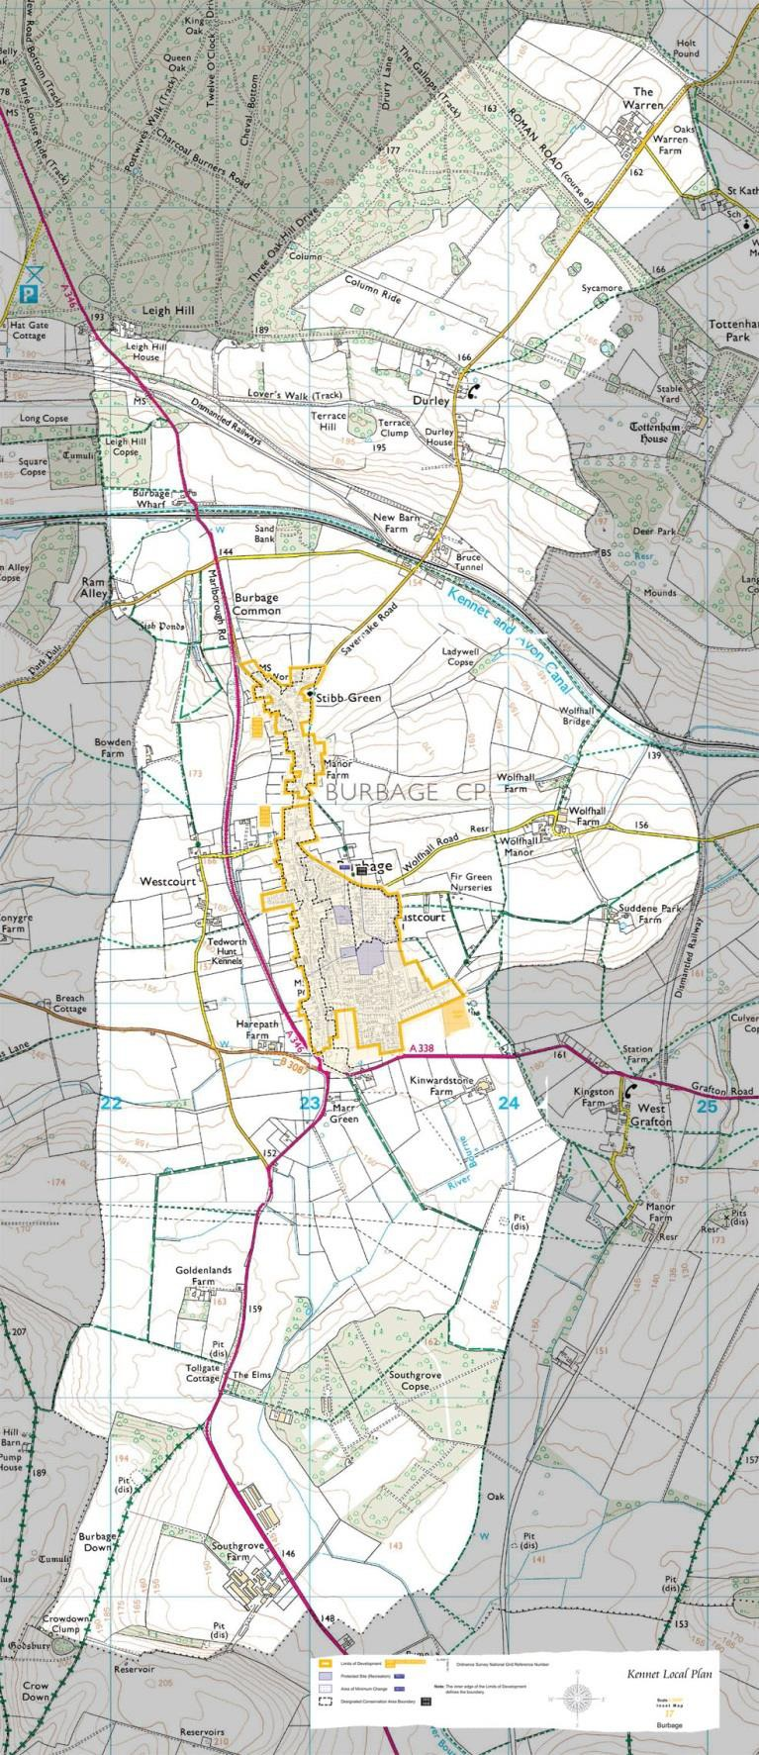

Appendix 3 Housing Needs Survey

Burbage

Parish Housing Needs Survey
Survey Report February 2014

Wiltshire Council
County Hall, Bythesea Road, Trowbridge BA14 8JN

Contents Page
Parish summary 3
Introduction 4
Aim 4
Survey distribution and methodology 5
Key findings 5
Part 1 – People living in parish 6
Part 2 – Housing need 10
Affordability 13
Summary 14
Recommendations 15

- Parish Summary

The parish of Burbage is in the Pewsey Community Area within the local authority area of Wiltshire.

- There is a population of 1,772 according to the 2011 Census, comprised of 728 households.1
- There were approximately thirty more dwellings recorded in the parish in the 2011 than in the 2001 Census.
- Burbage lies on the north-south route of the Marlborough to Salisbury road where it crosses the Vale of Pewsey. It is located six miles south of Marlborough and just north of the junction of the A346, A338 and A3087.
- Burbage Parish evolved from the settlements of Stibb Green, Durley, Wolfhall, Seymour and Marr Green on the periphery of the Savernake estate.
- Burbage High Street lies within the Burbage Conservation Area and the parish within the North Wessex Downs Area of Outstanding Natural Beauty.
- The village was voted the Best Kept Large Village in Wiltshire in 2013.
- Burbage is first mentioned in a charter of AD 961 as part of a large forest estate known as Bedwyn, which was granted to the Abingdon Abbey by King Edgar (Chandler 2001,Kennet District Council 2008). The place-name Burhbece is thought to derive from the Saxon burh and bece meaning ‘fortified settlement by a stream’ (Mills 1991). Facilities and services within the parish include:

  - All Saints’ Church (Church of England) and Church Centre.
  - Village hall – used by many local groups and for a monthly Saturday market and meet.
  - Burbage Primary School, Burbage Pre-School and Tiddlywinks Baby & Toddler Group.
  - Burbage Surgery.
  - A Royal British Legion Club.
  - Seymour Court retired/ sheltered housing.
  - Cricket, tennis, football clubs.
  - Two public houses and three bed and breakfast providers.
  - A grocers and a farm shop.
  - A service station.
  - A builders yard and related businesses.
  - A small unoccupied industrial estate.
  - Numerous clubs including Scouts, Brownies, Good Companions and Woman’s Own.
  - The Burbage News is published monthly and online quarterly. The Burbage website can be found at: http://www.burbage-life.com/

1 http://www.nomisweb.co.uk/ 2011 Census, table ks101ew (usual resident population) and 2011 Census, table qs405ew (tenure – households).
- Introduction

In late 2013, Wiltshire Council’s Development Officers discussed carrying out a rural housing needs survey with Burbage Parish Council, to establish if there was a proven need for affordable housing in the parish and potentially to use the findings of the survey to inform the parish plan.

Such surveys assist officers in identifying those areas with the greatest housing problems so that scarce financial resources can be put to best use.

Experience has shown that these surveys need to be carried out at regular intervals if the results are to remain relevant in identifying trends.

- The Principal Development Officers are employed by Wiltshire Council’s new housing team to assist in the delivery of new affordable housing.
- The Principal Development Officers work closely with rural communities, housing associations, local authorities and landowners to meet the affordable housing needs of rural communities.
- The survey is funded by members of the Wiltshire Rural Investment Partnership (WRIP).2
- ‘The Wiltshire Rural Investment Partnership brings together representatives from the economic development, regeneration, spatial planning, new housing and housing strategy teams of Wiltshire Council together with Registered Provider [housing association] partners and the Homes and Communities Agency to enable and promote the sustainable delivery of new build housing in the rural communities of Wiltshire.’3

- Aim

The aim of carrying out the survey is to investigate the affordable housing needs of local people (or those who need to live in the parish or the locality) of Burbage parish.

- ‘Housing need’ can be defined as the need for an individual or household to obtain housing that is suitable to their circumstances.
- It implies that there are problems or limitations with the household’s current housing arrangements and that the household is unable to afford or to access suitable accommodation in the private sector.
- Such problems may be concerned with housing costs, size, location, layout, state of repair, or security of tenure either immediately or in the future.

2 The members of WRIP that contribute to the survey funding are Wiltshire Council and seven Registered Providers of social housing (housing associations) - Aster, GreenSquare, Guinness, Jephson Housing, Raglan Housing, Selwood Housing and Wiltshire Rural Housing Association.
3 Para 1.1, ‘Purpose’, Terms of Reference for the Wiltshire Rural Investment Partnership. Full WRIP membership: Wiltshire Council, Aster, Wiltshire Rural Housing Association, Raglan Housing Association, GreenSquare, Guinness, Jephson Housing
Association, Selwood Housing, the Homes and Communities Agency, and the Wiltshire Community Land Trust.

- Survey Distribution and Methodology

In order to carry out the housing needs survey, questionnaires were delivered to the Parish Council for distribution from the 2nd January 2014.

To encourage a good response, households were given a pre-paid envelope in which to return the completed survey. The council applies the data protection policy to responses, ensuring that all survey responses remain anonymous.

Residents were asked to return the completed surveys in the pre-paid envelopes by 31st January 2014. The forms were recorded and analysed by the Housing Strategy department at Wiltshire Council.

  - A total of 768 questionnaires were distributed to the parish.
  - Everyone was asked to complete the first section of the form.
  - If a household considered itself in need, or likely to be in need, of affordable housing within the next five years, it was invited to complete the rest of the survey.
  - There was an excellent response rate of 40.1% with 308 replies received.
  - The received data refer only to themselves (i.e. to the survey respondents) and should not be taken as indicative of the wider population of Burbage parish.
  - Twenty four responses were made online.

- Key Findings

This report is divided into two parts. The first section looks at existing households in the parish in order to provide a description of the current housing in Burbage. This section also describes the levels of new affordable housing, if any, which would be supported by respondents to the survey.

The second section examines the households who have declared a need for new housing in Burbage. The section begins by describing the overall housing needs expressed by the survey respondents. A financial housing assessment is then made in order to determine the numbers of households who have a current need for new affordable housing. The results of this assessment are summarised in the recommendations of the report (Section 8).

Part One – Households currently living in the parish

The first question asked on the survey was whether the respondents’ home in Burbage was their main home. 99.3% replied that it was.

The 2011 Census data for Burbage indicates that 71.2% of households in the parish were owner-occupying, 13.7% were renting from social landlords, 10.7% were privately renting, 1.8% were living in shared ownership (part rented, part owned) homes and 2.6% of households were living rent free.4

The chart below shows the tenure of respondents to the survey. The majority (83.8%) of respondents were owner-occupiers, while 9.2% of respondents were living in socially rented properties, 5% were renting from a private landlord or letting agency, 1% were living in shared ownership homes and 1% in accommodation tied to their employment. These results indicate a bias in the survey responses toward owner-occupiers, and the rest of this section should be read with this in mind.

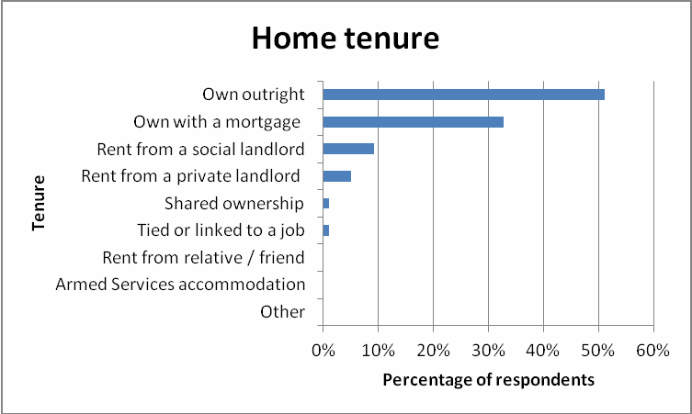

4 http://www.nomisweb.co.uk/
The chart below indicates the length of time that respondents have lived in Burbage. The majority of people who responded to the survey have lived in the parish for more than ten years, which is appropriate for the high levels of owner occupation among the survey respondents:

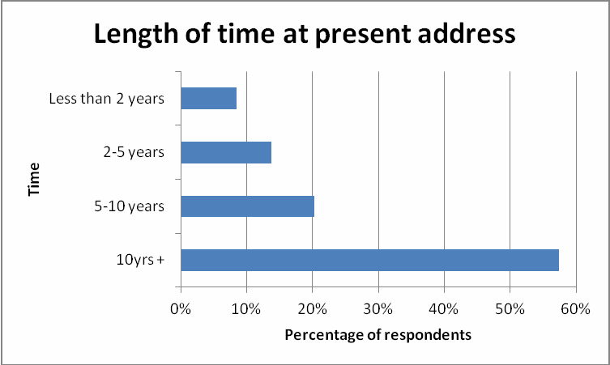

Many respondents to the survey lived in large family homes, with 12.2% of respondents having five or more bedrooms in their property. 33.7% lived in four bedroom homes, 34% had three bedrooms, 15.8% two bedrooms and 4.3% of respondents lived in homes with one bedroom.

The spread of ages recorded in the survey indicates that 26.8% of respondents’ household members were aged 65+:

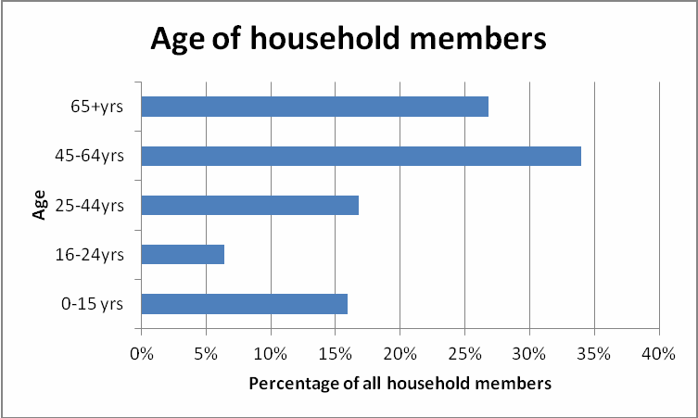

As shown in the chart above, however, there were significant proportions of households responding to the survey with members aged 25-64 and with children aged under 16. This
suggests a variety of different household types in Burbage, from older person households with fewer members, to younger households with children.

The distance travelled to work can also be a good measure of the sustainability of local housing development, as more people working locally can indicate an ongoing need for local housing. The table below shows how far people in the respondents’ households travelled to work:

Persons in household | Distance to work
Persons in household | Up to 2 miles | 2 - 10 miles | 10 - 50 miles | 50 miles + | Total
Person 1 | 32 | 42 | 82 | 22 | 178
Person 2 | 24 | 37 | 31 | 18 | 110
Person 3 | 2 | 9 | 2 | 1 | 14
Person 4 | 0 | 2 | 1 | 0 | 3
Person 5 | 0 | 0 | 0 | 0 | 0
Total | 58 | 90 | 116 | 41 | 305

These results suggest a mixed level of sustainability for new housing development in Burbage, indicated by the survey respondents. While 48.5% of households’ working members usually travel less than ten miles to their place of work, 51.5% travel more than that, suggesting a potential lack of more local sources of employment.

Respondents were also asked whether anyone currently living in their household would need separate accommodation in the parish now or in the near future, to which 7.7% of respondents answered ‘yes’, indicating a sustained need for housing in the parish.

Respondents were then asked how many new homes they would support being built in the parish. A majority of respondents (85.7%) were in support of some new housing in Burbage parish, with the most popular option (26.2% of respondents) being for between twenty one and forty new homes. 14.3% of respondents were opposed to any new housing in Burbage parish:

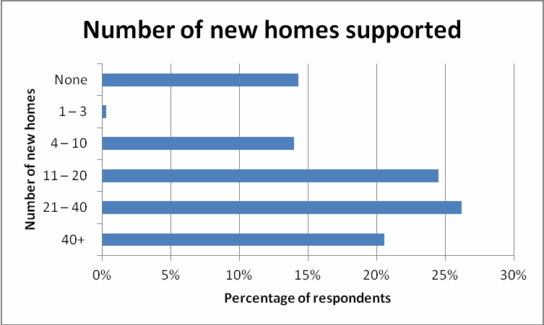

Respondents to this section were finally asked what types of housing development, if any, they would support. The types of homes considered most needed in Burbage by the survey respondents were affordable starter homes for young people (73% of respondents) and family accommodation for rent (43.3%). Full results are given in the chart below:

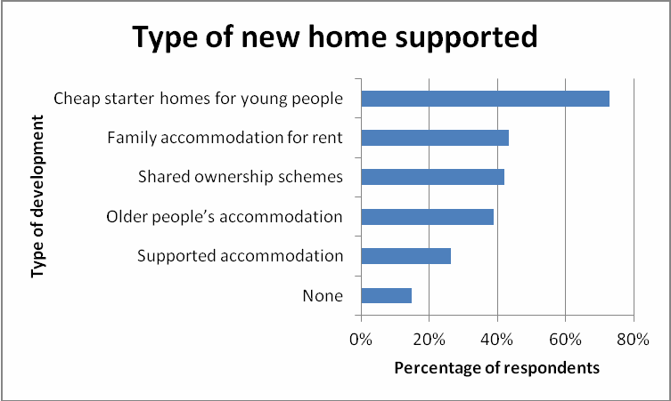

Part two – Households requiring accommodation in the parish

This part of the report looks initially at all the responses to section two of the survey in order to give a broad picture of the housing needs expressed by the survey respondents. A financial assessment and an evaluation of the current affordable housing in Burbage are then described in order to present the need for new affordable housing (Section 8).

Twenty seven respondents replied to this section of the survey, indicating their need for new housing in Burbage. Twenty five declared a local connection to the parish, either currently living or working in Burbage, having previously lived there, or having family members who currently live in the parish. The most popular reason for needing to move was that the respondents were currently living with their families, and want to live independently in the parish.

The respondents requiring accommodation in the parish were asked what type of tenure they sought. The expressed need was for all types of tenure, with purchased properties the most desired. Households could indicate more than one response:

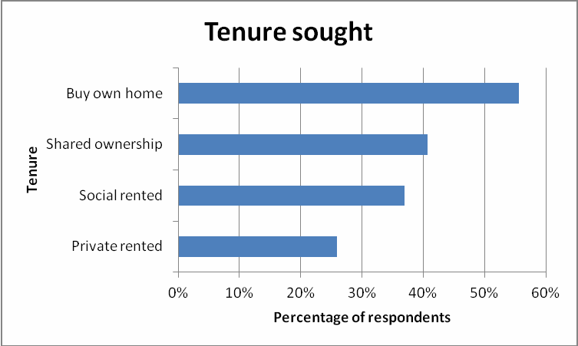

Respondents to this section were also asked what type of housing they required. The most sought-after types of homes were semi-detached properties. Full responses are given in the chart below (more than one answer could be given):
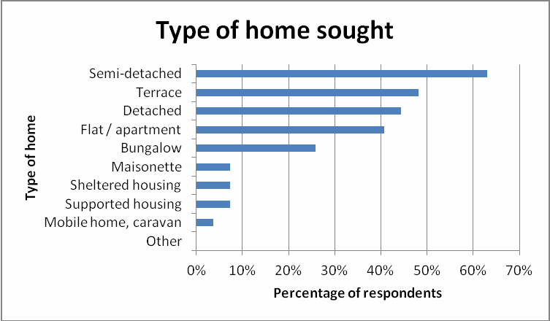

In terms of size, the most popular option was for two bedroom homes, but respondents also expressed need for properties with one, three and four bedrooms. No need was declared for homes with five or more bedrooms:

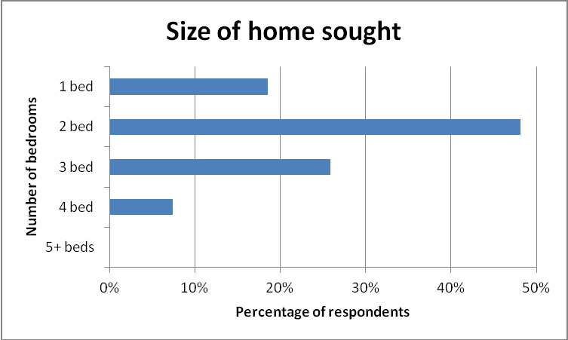

In order to assess the need for affordable housing in Burbage, it is necessary to consider the equity, income and savings levels of respondents. Please note that due to the need to preserve the confidentiality of respondents, only a short summary of the financial assessment is presented below. Please note as well that three respondents did not complete this section of the survey and so cannot be included in the financial assessment.

Four of the twenty-four households responding to this section of the survey reported having equity in an existing property and, for three of these, the estimated value remaining after loans and mortgages were paid off was in excess of £120,000. Thirteen households declared savings, of which six had less than £5,000, and two more than £200,000. Income levels were similarly varied, with two households on low gross household incomes of less than £15,499 and one on a high gross income of £75,000+. The median gross income of households responding to the financial questions was £26,000-£28,999pa.

Comparing income, savings and equity levels with affordability in Burbage suggests that seven of the twenty four households who completed the financial questions would not require public support in order to achieve their required housing.

The remaining seventeen households would be considered ‘in housing need’ as defined in Section 3 of this report. These households inform the recommendations of this survey for new affordable housing in Burbage, presented in Section 8.

Of the households meeting the criteria for affordable housing, 52.9% were headed by people aged 25-44, 41.2% by people aged 45-64 and 5.9% were headed by people aged 65+. Six households included children aged under 16.
- Affordability

In order to investigate affordability, further research has been carried out on house prices in the area.
It is possible to estimate the average property prices in the Burbage area:5

Bedrooms | Aug 2013 – Nov 2013
1 | £180,800
2 | £244,300
3 | £299,000
4 | £451,300
5+ | £684,200

Example calculation for a mortgage

Typically, a household making a single application can obtain a mortgage of 3.5 times their annual income, or 3x annual income for joint applications. Households would generally expect to need a deposit of around 15% of the total price.

If an average two-bedroom property sold in Burbage cost £244,300 then a household may require £36,645 as a deposit. Annual household income would have to be at least £59,330 for a single applicant or £69,218 for joint applicants. The Annual Survey of Hours and Earnings indicates that the gross annual median income of employed persons in the Kennet area in 2011 was only £21,712:6

- It would be unlikely that a household would be able to purchase a property in this parish without a large deposit, some equity in an existing property or a substantial income.

- First time buyers would generally struggle to meet the criteria necessary for obtaining their own home.

- In some cases intermediate housing (shared ownership or low cost market housing) would be a suitable option, whilst in other instances affordable rented accommodation would be appropriate.

5 House price estimates from the mouseprice local area guide to the SN8 postcode area, http://www.mouseprice.com/area- guide/average-values/sn8. Please note that the SN8 postcode covers a wider area than Burbage parish and that there may be significant internal variation in house prices.
6 Annual Survey of Hours and Earnings, 2011, Table 8.7a, Office of National Statistics, http://www.ons.gov.uk . Note that while the mortgage calculation refers to household income, i.e. to the combined income of all persons in the home, the ASHE
figure refers to individual income.
- Summary

This survey’s recommendations (see Section 8 below) concentrate on those households who are unable to afford accommodation on the open market.

The following indicates the minimum need over the next three years for new affordable housing, based on the responses to the survey. Please note that this report provides a description of the affordable housing need only of those who responded to the survey, and as such may underestimate the total affordable housing need in this parish.

  - At the end of the second quarter of 2013/14, there were forty-four households on the Wiltshire Council Housing Register seeking affordable accommodation in Burbage parish: six of these households are also described in Section 8 of this report as in need of affordable housing. The remaining households are seeking homes with between one and three bedrooms, and any full assessment of housing need in the parish must take account of the Register.7

  - The 2011 Census recorded one hundred social homes in the parish.8 These properties represent 13.7% of the total housing in Burbage, which is very slightly lower than the Wiltshire affordable housing average of 14.7%.9

  - Social housing in Burbage had a 9% re-let rate in the past year: from the first to the fourth quarter of 2012/13, nine social homes were re-let in the parish.10 Only two of
these, however, were general needs properties, while seven were sheltered properties for which preference in the letting process is given to households aged 55+.

  - The low turnover of general needs accommodation in Burbage suggests that none of the households responding to section two of this survey and in need of affordable accommodation could meet their needs through accessing the existing social housing of the parish.

  - While this survey’s recommendations describe the need for affordable housing (see Section 8 below), it should be noted that of the seven households responding to the financial questions and deemed not to be eligible for affordable housing, all but one described a lack of suitable accommodation in Burbage parish. These households possess the financial capacity to either rent or purchase open-market accommodation and their description of the lack of such suggests a potential need for an open-market or mixed tenure development in the area.

7 Wiltshire Council, Housing Strategy, live tables.
8 Table QS405EW, 2011 Census: Tenure – Households, English parishes / Welsh communities. 9 Table QS405EW, 2011 Census: Tenure – Households, local authorities in England and Wales. 10 Wiltshire Council, Housing Strategy, live tables.

- Recommendations

This survey’s recommendations concentrate on households unable to afford accommodation on the open market.

The following indicates the minimum need over the next three years for new affordable housing development in the parish, based on the responses to the survey.

The survey is only a quarter of the evidence required to fully assess housing need in the parishes. Wiltshire Council’s Housing Register, the Strategic Housing Market Assessment, and the advice of allocation staff who manage the Register must also be taken into account in fully determining local housing need.

Subsidised rented housing 11

  - 4x one bedroom homes (1x supported, single-level home providing assistance with personal care and access to an emergency support system such as Lifeline)
  - 1x two-bedroom home
  - 3x three bedroom homes
  - 1x four-bedroom home (wheelchair accessible)

Shared / Low cost home ownership

  - 5x two bedroom homes (1x single level)
  - 3x three bedroom homes

Sheltered housing for older people

  - None

11 Please note that recommendations for numbers of bedrooms in subsidised rented properties are where possible made in line with the ‘family size’ criteria implemented as part of the Housing Benefit changes by the 2012 Welfare Reform Act.

Appendix 4 Burbage and the AONB

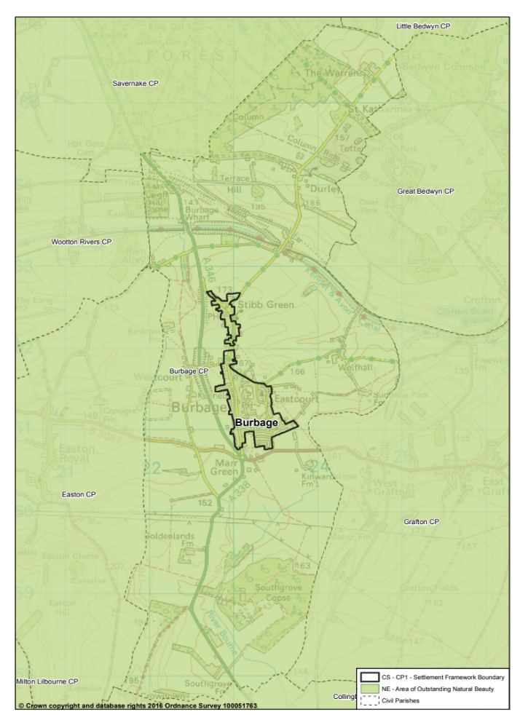

Appendix 5 Burbage and Heritage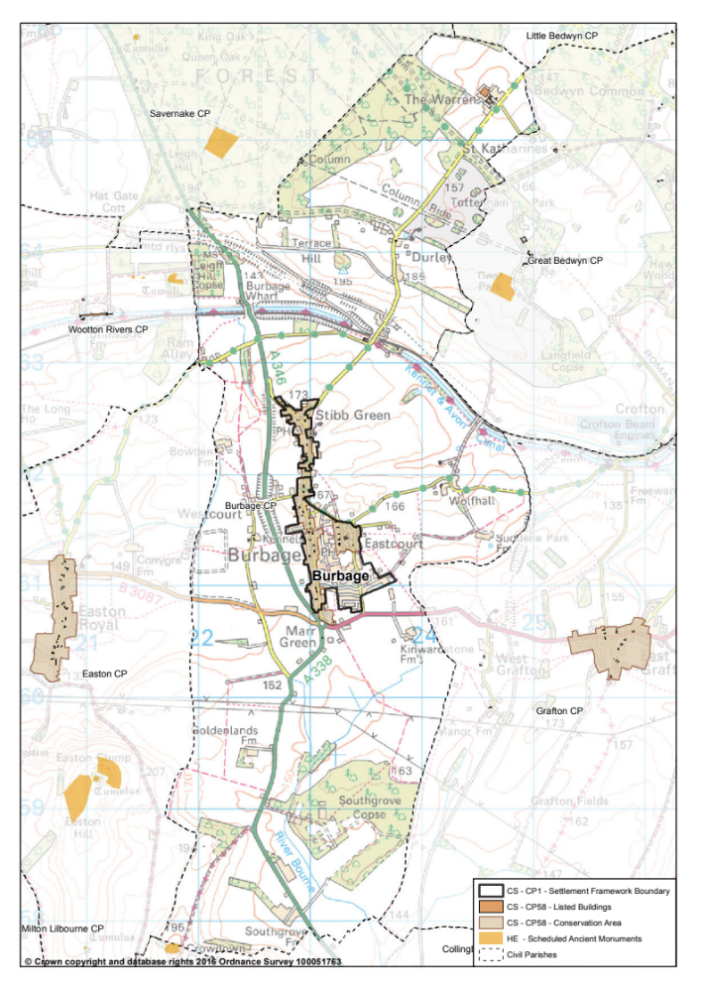
Appendix 6: Burbage and Flood Risk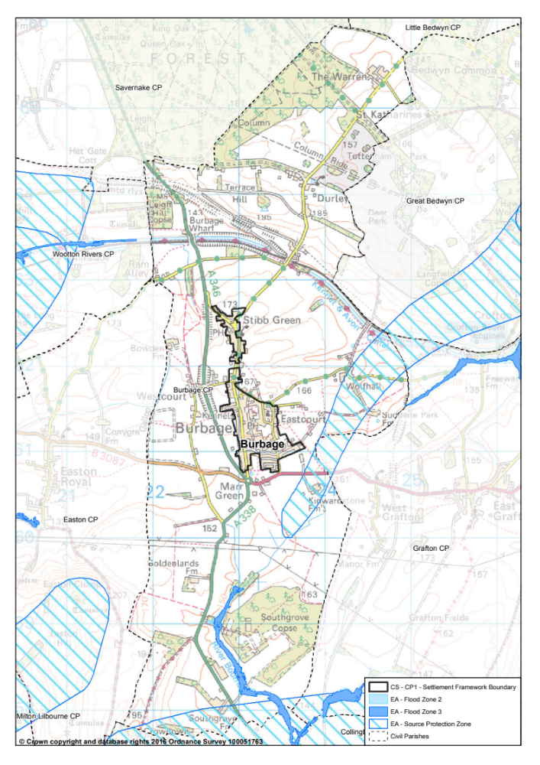

Appendix 7: Sites


